|  |
| --- |
| Qualifications and Experience  Research assistant with 4 years of experience in program evaluation  Master of Public Health from Indiana University |

1. **Emily L. Abbruzzi - Project Assistant**

**Summary**

Emily Abbruzzi is a research assistant with 4 years of experience in program evaluation. At Westat, she serves as a project manager for several evaluations of homelessness systems and the community supports for children and families. She collects and analyzes qualitative and

quantitative data, visualizes data for presentations, and helps edit reports. Her graduate work used structural equation modeling to examine the direct and indirect effects of couples’ safe sex practices. She is proficient in SPSS, SAS, MS Excel, EndNote, and NVivo.

# Education

M.P.H., Indiana University, 2016

B.A., Human Biology, Indiana University, 2014

# Relevant Project Experience

*Westat (2016 to Present), Rockville, MD*

**Culture of Health Years 2 and 3 Progress Reports Client:** Robert Wood Johnson Foundation (RWJF)

The goal of this project is to assess the uptake and spread of RWJF’s Culture of Health Initiative by various groups over a 2-year period. The evaluation includes several tasks to better define a Culture of Health, develop tools to track its spread in different mediums, and learn how various organizations are operationalizing its concepts. As Project Manager, Ms. Abbruzzi is the central point of contact across all tasks. She organizes weekly meetings with task leads, subcontractors, and the client and coordinates site visits and telephone interviews. In addition, she has helped develop a rating tool that identifies whether or not a program, proposal, or policy fits into Culture of Health and is participating in case studies of organizations aligned with Culture of Health. Ms. Abbruzzi is taking part in visits to three sites and contributing to the analysis of interview data and writing of site reports. She has also conducted a literature review on housing authorities and supported development of a landscape assessment. Furthermore, she manages a 17-member expert advisory council by planning and coordinating meetings, helping develop presentations, and presenting findings to members and the client.

**Evaluation of the Youth Homelessness Demonstration Program (YHDP) Client:** U.S. Department of Housing and Urban Development (HUD)

In January 2017, HUD awarded $33 million to 10 communities through the YHDP, designed to facilitate the development of coordinated systems for preventing and ending youth homelessness. Westat is conducting a 4-year evaluation to examine how the communities are developing and implementing coordinated systems and how these systems are affecting the size and composition of the target population (youth who are homeless or at risk of homelessness, including pregnant/parenting, LGBTQ, and minor youth). Westat is performing site visits to the 10 YHDP sites and to 3 comparison sites, a web survey of all other communities across the country that have implemented a continuum of care approach, an

analysis of each site’s homeless management information system and other administrative data. Ms. Abbruzzi has helped develop early deliverables by gathering existing data on each site, helping write site reports, and editing the cross-site report. She is the liaison to the Connecticut site and conducts site visits.

# Cross-Site and Impact Evaluation of Mobilizing Action for Resilient Communities (MARC) Initiative

**Client:** Robert Wood Johnson Foundation

The overarching goal of this 3-year, multisite evaluation is to understand and assess the effectiveness of multisector community efforts for addressing adverse childhood experiences and promoting health and well-being among children and families. The evaluation involves 14 communities in 13 states; the Health Federation of Philadelphia, the national coordinating agency for MARC; and two online networks that promote this work. For each community, Westat is conducting an evaluability assessment to determine the key components of its action model, developing and/or refining the community’s logic model, and identifying appropriate outcome measures that will inform the overarching outcomes for the broader initiative. Westat is also providing each community with technical assistance on its own evaluation. Ms.

Abbruzzi edited the network surveys, programmed the surveys in SurveyGizmo, tracked response rates, and communicated with sites to increase response rates. She has analyzed quantitative data and made site visits.

**Washington Families Fund Systems Initiative Evaluation Client:** Gates Foundation

Westat is conducting a 10-year longitudinal evaluation of the Gates Foundation’s Washington Families Fund Systems Initiative. The purpose of the initiative is to change the overall homeless service systems in three local counties to increase coordination and data-driven decision making among local service providers such that they can reform their systems to prevent family homelessness among those at risk and, for those who experience homelessness, facilitate rapid re-entry into housing and linkage to needed services and economic opportunity. Westat’s evaluation is a comprehensive examination of the process and outcomes of the initiative in all three counties. Ms. Abbruzzi has helped maintain data quality during weekly team meetings when interview data is reviewed and checked for interviewer errors. She has coded interviews in NVivo, assisted with data visualization, and prepared graphs and charts for reports and presentations. She has also scheduled site visits.

**Washington Families Fund High-Need Families (HNF) Initiative Client:** Washington Families Fund (WFF)

The WFF’s HNF initiative is a coordinated, intensive housing and services model for high- need families in the State of Washington. Westat is assessing the extent to which the initiative is successful in helping families connect with community-based services, decrease their use of high-cost services, and achieve stability. The evaluation has implementation and outcome components and is expected to continue over a 6-year period. Westat is leading development of a baseline family assessment tool and a 6-month follow-up tool, development of a framework and measures for assessing site implementation of the model, and design of a study of the effectiveness and costs of the demonstration, to be conducted in subsequent years. Ms. Abbruzzi assisted with data cleaning and analysis.

# Emily L. Abbruzzi - Statement of Availability

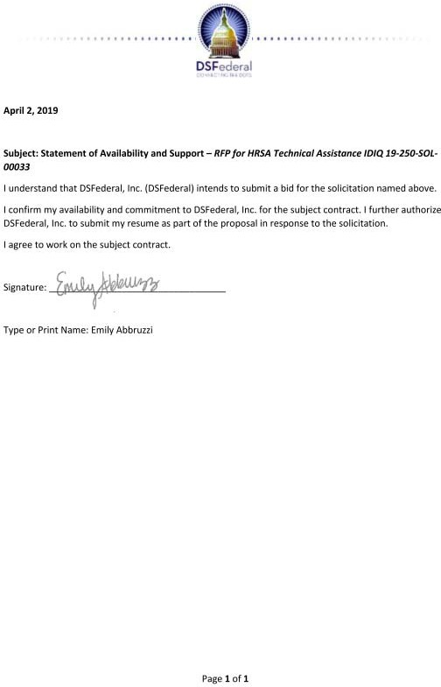

|  |
| --- |
| Qualifications and Experience  Editor and writer with 20 years of experience in health research  Bachelor’s in psychology from Pace University |

1. **Patricia Andersen / Consultant - Meeting Technical Writer/Editor Summary**

Patricia Andersen is an editor, writer, and fact checker with more than 20 years of experience in research, analysis, and the development of operational workflow procedures. She has diverse experience in the health industry, with various Federal health-related contracts and Federal health insurance. Ms. Andersen worked with NCCIH

Information Services for more than 15 years. She provides editing and quality control services and contributes her experience with various style guides to a range of projects.

# Education

B.A., Psychology, Pace University, 1972

# Relevant Project Experience

*Westat (2009 to Present), Rockville, MD*

# Health Marketing Support Services

**Client:** Office of the Associate Director for Communication, Centers for Disease Control and Prevention (CDC)

Westat provides expertise and support for CDC health communication programs covering a broad range of health topics and targeting a variety of audiences. Project staff conduct research to inform program planning, including concept and message testing, literature reviews, environmental scans and situational analyses, and audience identification and segmentation. Westat develops strategic communication plans and plans, implements, and evaluates social marketing campaigns. Below are several examples of projects for which Ms. Andersen has provided editorial services, including fact checking, reporting, and quality control of social media and promotional materials.

# Act Against AIDS (AAA) Campaign: Expansion and Dissemination of a National HIV Prevention and Testing Campaign

Westat developed and successfully launched “Doing It. Testing for HIV,” a new national HIV testing campaign. Westat is currently working with CDC to disseminate the campaign to general audiences and those at increased risk for HIV. To date, the team has garnered more than 700 million media and digital impressions, led nine social media activations that engaged over 3 million users, supported 13 community engagement events that reached more than 500,000 people, and tested over 400 participants.

# Promoting Childhood Immunization to Parents and Healthcare Professionals Using Communication and Social Marketing Strategies

Westat worked with CDC’s National Center for Immunization and Respiratory Diseases to develop and implement a social marketing campaign to promote childhood immunization to the parents of infants and young children and to child care and healthcare professionals.

Project staff conducted research—including a pilot project targeting English and Latina

pregnant women and OB/GYNs—to inform development of public health communication strategies about pertussis.

# State-Based Profiles on Restraint Use and Alcohol-Impaired Driving

CDC’s National Center for Injury Prevention and Control partnered with Westat to create a series of state profiles describing the burden of motor vehicle crash injuries and deaths as it relates to restraint use and alcohol-impaired driving. The team analyzed publicly available data and evidence-based public health strategies to tailor the profile data for each state.

Westat’s graphics and editorial teams designed and wrote profiles that are appealing and useful for a broad range of audiences, including state health departments and their constituents.

# Adaptation of AMIGAS for African American Women Never and Rarely Screened for Cervical Cancer

**Client:** Centers for Disease Control and Prevention (CDC)

Ayudando a las Mujeres con Información, Guía y Amor para su Salud (AMIGAS) is a community-based intervention program connecting researchers, healthcare workers, and program administrators to research, design, and implement methodologies for educating Hispanic women about cervical cancer screening. Under this contract, Westat is supporting CDC in evaluating the applicability and transferability of the AMIGAS intervention to modify the health behaviors and outcomes of African American women who have never had cervical cancer screening or have not been screened in the past 3 years. Ms. Andersen helped develop numerous training materials and aids to educate African American women about cervical cancer and to encourage screening. She also tested the materials and the training process for community health workers.

# National Center for Building State Capacity and Productivity (BSCP Center)

**Client:** Office of Elementary and Secondary Education, U.S. Department of Education (ED) The BSCP Center, one of eight Comprehensive Centers established by ED, provides technical assistance to 15 Regional Comprehensive Centers and to state education agencies (SEAs) as they adapt to reduced fiscal resources and increased productivity demands. The center helps SEAs build their capacity to support local education agencies and schools. Westat/Edvance Research provides three levels of technical assistance: direct access and dissemination of print and electronic material, interactive assistance (groups of states working on a common problem), and intensive assistance provided directly to an individual state. Also under this contract, Ms. Andersen provided editorial/quality verification services on materials such as the BSCP Center Toolbox webinar series, which supports education professionals and agencies in developing strategic communications plans.

# Other Professional Experience

*Lockheed Martin/Aspen Systems, Rockville, MD (2001 to 2009)*

As senior technical editor/writer, Ms. Andersen facilitated publication and distribution of NCCIH’s newsletter, provided editorial services on a wide variety of materials to ensure product quality and timeliness. She was involved with all aspects of written correspondence, including writing, editing, procedures and guidelines development, and staff training.

# Patricia E. Andersen - Statement of Availability

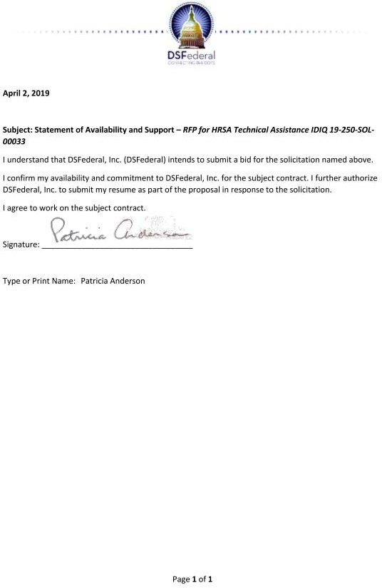

|  |
| --- |
| Qualifications and Experience  Research analyst with 7 years of experience in health services research  M.P.H. from the University of Virginia  Experienced with survey development |

1. **Nina Freed - Data Technician Summary**

Nina Freed is a research analyst with 7 years of experience in health services research. At Westat, she focuses on health care quality measurement and public reporting of quality information. She has significant experience in concept testing and website usability testing for clinician

quality projects, Ms. Freed leads a team that writes and tests quality measurement language to ensure that publicly reported Medicare quality program information is useful for Medicare patients and caregivers. Ms. Freed has additional expertise in cognitive and in-depth interviews, qualitative and quantitative data analysis, and report writing.

# Education

M.P.H., Health Policy, Law, and Ethics, University of Virginia, 2015

B.A. (cum laude), Psychology, University of Virginia, 2011

Additional Training: Cognitive Interviewing: A Hands-On Approach (short course), Joint Program in Survey Methodology, 2012

# Relevant Project Experience

*Westat (2011 to Present)*

**Evaluation of the Part D Enhanced Medication Therapy Management Model (EMTM) Client:** Centers for Medicare & Medicaid Services (CMS)

Westat is helping to design and conduct a mixed-methods evaluation of the EMTM model demonstration to examine whether providing basic, standalone prescription drug plans (PDPs) with additional payment incentives and regulatory flexibilities for offering innovative MTM programs will improve Medicare beneficiaries’ quality of care and experience while reducing healthcare costs and utilization. Westat is leading qualitative data collection and analysis, including interviews with industry stakeholders and experts, 22 participating PDPs, and beneficiaries; site visits to a subset of PDPs; and surveys of prescribers and staff implementing EMTM programs. Ms. Freed leads coordination of a web-based workforce and prescriber surveys for PDPs offering MTM programs. She contributes to survey development, cognitive testing, and development of sampling frames; and contributes to data analysis. She also assists in interviewing Medicare beneficiaries who have received or declined EMTM services.

**Physician Compare Website Implementation Support Client:** Centers for Medicare & Medicaid Services (CMS)

**Project Overview:** Westat has had two contracts to facilitate implementation and generally support all work related to the Medicare.gov Physician Compare website and public reporting of physician performance data. Ms. Freed leads concept testing of quality measures available for public reporting on the Physician Compare website. She led the team in developing plain language measure titles and descriptions based on a detailed review of measure specifications for more than 200 Physician Quality Reporting System and Qualified Clinical Data Registry

measures. Ms. Freed coordinates with the Accountable Care Organization (ACO) team on language used to publicly report ACO quality information. She also contributed to updates of the CMS Measures Management System Blueprint for patient engagement and technical expert panel processes. For the Physician Compare home page, Ms. Freed led development of an intelligent search database that links more than 20,000 search terms to Medicare specialties. She maintains the Intelligent Search and Search Another Way databases, incorporating input from medical stakeholders.

# Integration Implementation Playbook

**Client:** Agency for Healthcare Research and Quality (AHRQ)

**Project Overview:** This project was part of Westat’s work supporting AHRQ in building the Academy for Integrating Behavioral Health and Primary Care, a collaborative environment to foster dialogue among leaders who treat mental/substance use disorders and provide primary care. Ms. Freed led coordination of the web-based Integration Implementation Playbook web application development team. She conducted usability testing with primary care clinicians and contributed to development of the Playbook’s Self-Assessment Checklist.

# Academy for Integrating Behavioral Health and Primary Care Client: Agency for Healthcare Research and Quality (AHRQ)

**Project Overview:** The goal of the AHRQ Academy for Integrating Mental Health and Primary Care is to function as a coordinating center and a national resource for people committed to the availability of health care that integrates mental health and substance use treatment with primary care. Westat is supporting AHRQ grantees in five states in their efforts to make medication-assisted treatment (MAT) for opioid use disorder (OUD) more widely available in rural primary care settings by (1) assembling available knowledge and providing technical assistance about MAT models, their implementation and effectiveness in rural settings, and potential barriers; (2) supporting communication and peer-to-peer technical assistance among grantees; and (3) sharing information and resources more broadly with others addressing the challenge of implementing MAT for OUD in rural primary care settings. Other key tasks include (1) convening a National Integration Academy Council composed of leaders across disciplines who share an interest in integrated care and (2) developing a web portal to support networking, collaboration, and information dissemination. In support of these tasks, Ms. Freed conducted interviews with group practices with integrated health IT systems and wrote case study summaries that were posted on the Academy website. She also developed a framework for adding clinical measurement tools to the Measures Atlas on the portal.

# Presentations

Freed, N., Korsen, N., and Muther, J. (2016, October). Experiences using the AHRQ Academy Playbook – a web-based guide to integrate behavioral health in primary or other ambulatory care settings (panel presentation presenter). Collaborative Family Healthcare Association Annual Conference, Charlotte, NC.

Freed, N. (2016, June). *Exploring the correlation between HCAHPS communication scores and hospital-wide readmission rates* (poster). Academy Health Annual Research Meeting, Boston, MA. Available at: https://academyhealth.confex.com/academyhealth/2016arm/meetingapp.cgi/Paper/10375.

# Nina Freed - Statement of Availability

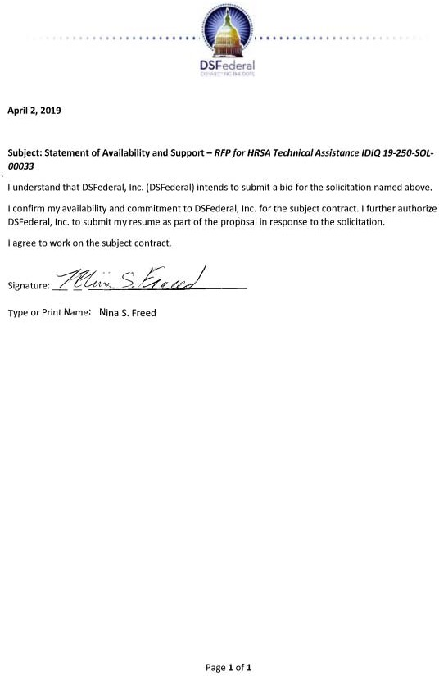

|  |
| --- |
| Qualifications and Experience  Web designer with 15 years of experience developing innovative, user-centered designs for health information websites  B.A. from the Florida State University  Merit Award (for NEI website), Digital Health Awards |

1. **Noemi Lucciola - Website Designer Summary**

Noemi Lucciola is a senior web designer with 15 years of experience developing innovative, user-centered designs for health information websites. She is experienced in user interface design, wireframing, and theme site design. She has managed the web teams for NCCIH and NEI, coordinating daily priorities and

improvements for intranet and public sites. Ms. Lucciola’s skill areas include design, redesign, graphics optimization for the web, CMS theming using modern responsive frameworks, and Section 508 compliance.

# Education

Certificate Program in Computer Graphics, Corcoran School of Design, Corcoran School, 1998 B.A., Art History, Florida State University, 1993

# Relevant Project Experience

*Westat and Eagle Design & Management (1996 to Present) (Eagle Design & Management was acquired by Westat in 2006)*

**Children’s Health Exposure Analysis Resource (CHEAR): Coordinating Center Client:** National Institute of Environmental Health Sciences (NIEHS)

CHEAR is being established to provide a range of sophisticated laboratory analyses and data services to researchers interested in exposure science and children’s health. As the Coordinating Center (CC), Westat’s primary roles are to create and maintain a comprehensive index of CHEAR laboratory and data services, methodologies, and expertise available to researchers and to provide a public website for researchers to access network information and initiate proposals for projects involving CHEAR resources. The CC is responsible for establishing and managing proposal submission and evaluation processes, tracking services workflow, and defining quality standards by which CHEAR performance is measured. Other tasks include supporting standardization of laboratory analyses and processes, organizing and supporting oversight committees, developing a strategic communication plan, and leveraging the CHEAR public website and social media to facilitate communication with the broader scientific community. Ms. Lucciola is responsible for the design and production of the public- facing website. She created wireframes, graphic assets, the Drupal build, and theming using responsive frameworks.

**National Center for Complementary and Integrative Health Information Services Client:** National Center for Complementary and Integrative Health (NCCIH)

Westat provided comprehensive information services support for the NCCIH (formerly NCCAM) Office of Communications from 2009 to 2017. The project team developed or updated more than 100 evidence-based factsheets, research spotlights, continuing education video lectures, and interactive quizzes (some with CME/CEU) each year. Westat operated the NCCIH clearinghouse—the primary point of contact for consumers, health professionals, and

policymakers seeking timely and accurate information on complementary and integrative health approaches—responding to multichannel inquiries in English and Spanish. Project staff planned and implemented NCCIH’s exhibit program and operated inventory and fulfillment. Ms. Lucciola designed, developed, and hosted the client’s public-facing website and intranet, using the Drupal framework. The content and website won design, public health, and plain language writing awards. Westat also helped NCCIH develop and implement a social media strategy that reached multiple audiences and built engagement.

**Support for the National Eye Institute’s Education and Communication Programs Client:** National Eye Institute (NEI)

Westat provided technical and logistical support for education and public outreach activities coordinated by the Public Liaison and Education Branch of NEI’s Office of Science Communications, Public Liaison, and Education. Project staff supported communications activities to public inquiries; inventory management and publications distribution; content development and graphic design for print and online materials; website development, design, and maintenance; support for NEI exhibit programs; and other outreach and education efforts. Westat managed and operated the NEI websites and a variety of interactive applications and specialized portals, including an online knowledgebase; a photograph, image, and PSA catalog; a clinical studies database; the NEI intranet; a database of eye health resources; an online publications catalog with a secure system for credit card orders; and an online workflow tracking system. Ms. Lucciola managed and was lead graphic designer for NEI websites for which she has won a number of awards. As team lead and liaison for this contract, she managed regular maintenance, monthly reports, and usability enhancements. She oversaw domain name selection, search engine optimization, meta tag development, and traffic analysis and established key links and affiliate programs. Ms. Lucciola worked with NEI to create sites that are visually accessible, using fonts and colors that are easier to see for those with low vision. She has created various theme sites, banner advertisements, and online newsletters, in addition to managing and maintaining content. In 2014, Ms. Lucciola managed and designed the migration of the NEI website into Drupal 7, working within traditional and modern CMS frameworks to deliver a completely rethemed and restructured site under strict deadlines.

# Selected Awards and Professional Achievements

* + Merit Award (for NEI website), Digital Health Awards, Fall 2015
  + Gold Award (for NEI website), Summer Web Health Awards, 2013
  + Bronze Award (for NEI’s See All You Can See), Winter/Spring Web Health Awards, 2011
  + Silver Award (for NEI website), World Wide Web Health Awards, 2010
  + Bronze Award (for NEI’s Eye on NEI), Plain Language, Clear Communication Award, NIH, 2010
  + Silver Award (for NEI’s See All You Can See), W3 Awards, 2008
  + Gold Award (for NEI’s See All You Can See), Marcom Awards, 2008
  + Merit Award (for NEI), World Wide Web Health Awards, 2008

# Noemi Lucciola - Statement of Availability

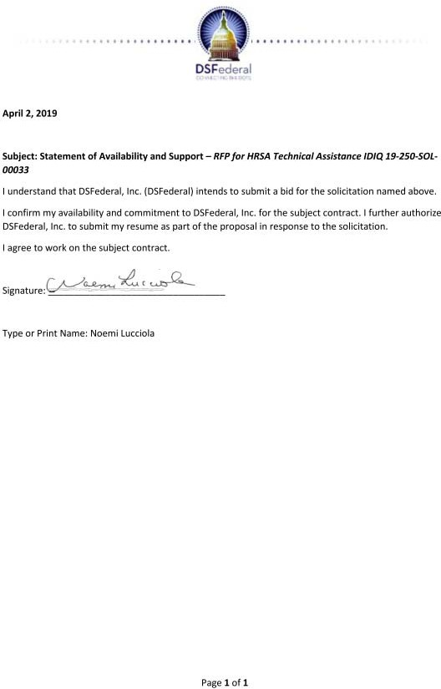

|  |
| --- |
| Qualifications and Experience  Health communications specialist with 10 years of experience using social marketing and design thinking  M.A. from Johns Hopkins University  Experience with developing Spanish language content |

1. **Sandra L. Paredes - Translator/Interpreter Summary**

Sandra Paredes is a health communications specialist with more than 10 years of experience supporting Federal health agencies using social marketing and design thinking. As a native Spanish speaker, she has over 15 years of experience writing, translating, and adapting heath information from English into Spanish. In addition, Ms.

Paredes has responded to health information

inquiries from public and professional audiences and provided support for promotional, outreach, and exhibit programs. She also has 10 years of experience in qualitative methods for health communication research.

# Education

M.A., Communication, Johns Hopkins University, 2013 B.A., Psychology, Cornell University, 2002

# Relevant Project Experience

*Westat and Eagle Design & Management (2005 to Present) (Eagle Design & Management was acquired by Westat in 2006)*

# Innovation Next – Stage 1

**Client:** National Campaign to Prevent Teen and Unplanned Pregnancy

Westat was among 10 teams chosen for the Innovation Next Awards, an incubator that uses design thinking to find a technological solution to teen pregnancy prevention. As part of the first cohort of Innovation Next, Westat learned the human-centered approach to creative problem solving through workshops led by the San Francisco-based global design firm, IDEO. For the 6-month pilot, Ms. Paredes developed original Spanish-language content for parents of 8- to 18-year-olds. She provided expert input during Q&A sessions with participants, and led the qualitative evaluation of the program.

**Listeria Focus Groups with Pregnant Women Client:** Food and Drug Administration (FDA)

Westat worked with FDA to conduct 18 focus groups with pregnant Hispanic women, pregnant non-Hispanic women, older adults, and health care providers to explore behaviors, motivations, and attitudes related to the risks of contracting listeria from soft cheeses. Westat provided expert review of discussion materials, convened focus groups, and submitted a summary report.

Ms. Paredes took notes during focus groups, translating Spanish words and concepts for the research team.

**Support for the National Eye Institute’s Education and Communication Programs Client:** National Eye Institute (NEI)

Westat provided technical and logistical support for education and public outreach activities coordinated by the Public Liaison and Education Branch of NEI’s Office of Science Communications, Public Liaison, and Education. Project staff supported communications activities to public inquiries; inventory management and publications distribution; content development and graphic design for print and online materials; website development, design, and maintenance; support for NEI exhibit programs; and other outreach and education efforts. Westat managed and operated the NEI websites and a variety of interactive applications and specialized portals, including an online knowledgebase; a photograph, image, and PSA catalog; a clinical studies database; the NEI intranet; a database of eye health resources; an online publications catalog with a secure system for credit card orders; and an online workflow tracking system.

As the senior bilingual health information specialist, Ms. Paredes responded to English and Spanish inquiries received from the public and health professionals, analyzed Twitter content, assisted in translating documents between English and Spanish and in developing Spanish- language content for the website and Twitter.

# National Children’s Study (NCS) Vanguard Study 2.0

**Client:** Eunice Kennedy Shriver National Institute of Child Health and Human Development (NICHD)

**Project Overview:** Westat served as the NCS Regional Operations Center (ROC) for the Western region of the NCS Vanguard Study 2. Under this contract, Westat transitioned data collection operations from 10 independent study centers in the Western Region to one ROC. Westat hired and trained field staff, developed the infrastructure to facilitate data collection, reconsented study participants, coordinated receipt of participant information and data from the Program Office-provided Information Management System, and developed procedures to track, follow up, and retain study participants. Project staff collected, managed, processed, and transmitted data, specimens, and environmental samples; monitored and evaluated field activities; and conducted outreach and engagement activities. Ms. Paredes tracked national and local media mentions of the study and helped identify nominees for the regional advisory committee.

# National Oral Health Information Clearinghouse (NOHIC)

**Client:** National Institute of Dental and Craniofacial Research (NIDCR)

Between 1993 and 2005, EDM initiated and operated NOHIC, which serves as a public resource on oral diseases, therapies, and prevention strategies. Each year, EDM responded to an average of 10,000 email, mail, fax, and telephone inquiries and distributed more than 1.2 million publications. Project highlights included redesign of the NOHIC website; coordination of a professional review of publications for an oral cancer campaign, including translation and adaptation for Spanish-speaking patients; development, formative research, and implementation of a national health education program on the oral health needs of people with developmental disabilities, including administration of a continuing education component; and identification and acquisition of oral health materials for the Combined Health Information Database. EDM staff also managed and attended approximately 12 national meetings and coordinated 20 or more national and international exhibits annually. As the bilingual health information specialist. Ms. Paredes responded to inquiries from the public and health professionals in English and Spanish.

# Sandra L. Paredes - Statement of Availability

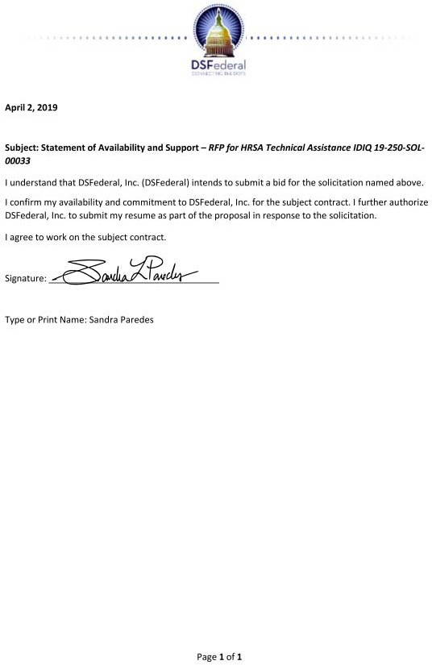

|  |
| --- |
| Qualifications and Experience  Senior Study Director with 25 years of experience in social science research  M.A. from George Washington University |

1. **Elizabeth A. Quinn - Project Manager Summary**

Elizabeth Quinn is a Westat Senior Study Director with more than 25 years of experience in social science research involving disadvantaged populations. She has directed and managed numerous child welfare and juvenile justice studies. Her extensive experience includes designing and implementing experimental and quasi-

experimental evaluations and preparing evaluation reports for technical and nontechnical audiences. In her previous work at CSR, Incorporated, Ms. Quinn participated in a wide range of research and evaluation projects, including program evaluations, program assessments, quick-turnaround policy studies, and analyses of large data sets. She contributed to all aspects of the research process, including study design; instrument development; data collection, analysis, and reporting; report production and presentation; and project management.

# Education

M.A., Public Policy and Women’s Studies, George Washington University, 1986 B.A., Psychology (with honors), University of Illinois, 1975

# Relevant Project Experience

*Westat (2000 to 2014, 2016 to Present)*

# Children’s Mental Health Initiative (CMHI) National Evaluation

**Client:** Substance Abuse and Mental Health Services Administration (SAMHSA)

Westat is leading a national evaluation of CMHI Systems of Care (SOC) planning grants and implementation grants. The evaluation plan includes a grantee introductory interview and document review, a stakeholder interview, a grantee self-assessment, financial mapping, benchmarking, a grantee SOC expansion assessment, a child and family outcomes assessment, a network analysis at the state and local levels, and the use of GIS to describe SOC expansion. Westat is developing instrumentation, delivering training and technical assistance to grantee data collectors, developing and maintaining a reporting system, analyzing and synthesizing data, and preparing reports to Congress and for other purposes.

Ms. Quinn analyzes and reports data and is leading the evaluation liaisons in their work with grantees.

**Evaluation of the Youth Homelessness Demonstration Program (YHDP) Client:** U.S. Department of Housing and Urban Development (HUD)

Westat is conducting an evaluation to examine how the communities are developing and implementing coordinated systems for preventing and ending youth homelessness and how these systems are affecting the size and composition of the target population. Ms. Quinn is performing site visits to the 10 YHDP sites and to 3 comparison sites and serving as a liaison with YHDP sites. Westat is also conducting a web survey of all other communities across the country that have implemented a continuum of care approach, and analysis of each site’s

homeless management information system and other administrative data. Ms. Quinn is also responsible for analyzing the survey and site visit data.

**New York City Center for Economic Opportunity (CEO) Program Evaluation Client:** New York City Mayor’s Office for Economic Opportunity (NYC Opportunity) (formerly Center for Economic Opportunity/New York City Human Resources Administration)

Westat is evaluating initiatives of the CEO Program, Mayor Bloomberg’s effort to move economically disadvantaged New Yorkers out of poverty. The Westat team is examining approximately 35 programs to determine which can best be evaluated, developing an evaluation design, and working with the selected programs to systematically collect information for evaluating impact, program implementation, and cost-benefit. Ms. Quinn managed an impact evaluation of Teen ACTION, an after-school service learning program for students in high-risk neighborhoods and directed an evaluation of the LIFE Transitions Program for youth transitioning out of juvenile detention into the community.

**Illinois Permanency for Older Wards Waiver Study Client:** Illinois Department of Children and Family Services

**Project Overview:** Westat evaluated the extension of the Illinois Subsidized Guardianship Waiver Demonstration. Data collection included analysis of administrative data, two interviews with youth and caregivers, focus groups with agency and court personnel, and administrative case reviews. As the Project Director, Ms. Quinn was responsible for all aspects of project performance. In addition, she directed the analysis of administrative and interview data and led report writing. She also led the design and implementation of the process evaluation and was responsible for determining outcomes for study youth in the administrative databases of other state agencies.

**National Juvenile Probation Census Project (NJPCP) Client:** U.S. Department of Justice (DOJ)

**Project Overview:** Westat and two subcontractors, conducted work on two component collections for OJJDP. The 2012 Census of Juveniles on Probation involved engaging stakeholders, collecting web survey data on probation cases from agencies, conducting weighting procedures, and developing state and national estimates. Westat also completed design work for a companion survey, the Census of Juvenile Probation Supervision Offices (CJPSO). Project staff redesigned the core and supplemental instruments for the CJPSO, which included conducting a literature review, developing design and methodology recommendations, conducting site visits to agencies, and drafting a complete core and supplemental instrument as well as blueprints for three future instruments. As the Project Director, Ms. Quinn was responsible for all aspects of project performance and led report writing.

# Selected Publications

Quinn, E. (2016). Selecting evidence-based practices. *Children’s Bureau Express*, 17(1).

Available at: https://cbexpress.acf.hhs.gov/index.cfm?event=website.viewArticles&issueid=174&articleI D=4699&keywords=Liz%20Quinn.

# Elizabeth A. Quinn - Statement of Availability

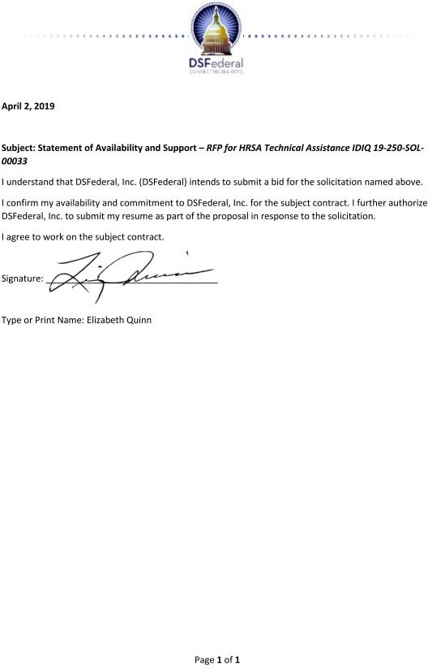

|  |
| --- |
| Qualifications and Experience  Recruitment manager with 14 years of experience in field operations  B.S. from the University of Texas  Provides technical assistance on a variety of projects |

1. **Stacey Hall Reddick - Senior Travel and Logistics Coordinator Summary**

Stacey Reddick is a recruitment manager with 14 years of experience in field operations for health-related research. At Westat, she provides technical assistance to CMHS grantees and Project Officers using the Transformation Accountability (TRAC) system. She has been responsible for recruitment, hiring, and management of field

and in-house staff for large-scale studies such as the National Hospital Care Survey, the Population Assessment of Tobacco and Health, and the Drug Abuse Warning Network, among others. Ms. Reddick previously supported on-site research studies involving a variety of data collection methods, including focus groups, mini-groups, triads, dyads, and one-on- one interviews. In her 20 years with Trans World Airlines, she held a variety of increasingly responsible management roles, with a focus on quality assurance measurements and evaluation systems to deliver effective and efficient client services.

# Education

B.S., Education, Texas, 1970

# Relevant Project Experience

*Westat (2004 to Present)*

# CMHS Transformation Accountability (TRAC)

**Client:** Center for Mental Health Services (CMHS), Substance Abuse and Mental Health Services Administration (SAMHSA)

The TRAC project provides a full range of support for accountability reporting and performance assessments for CMHS, including the Programs of Regional and National Significance and the Children’s Mental Health Initiative. The Westat team supports CMHS and its grantees through performance measure development, data entry and reporting systems development, and training and implementation support. Westat staff provide face-to-face and web-based training for CMHS grantees on all aspects of data entry and reporting, along with technical support through a dedicated helpdesk so grantees can access real-time reports on the to monitor performance. Ms. Reddick provides technical assistance to TRAC users to resolve issues related to grant program management, system navigation for data entry and review, grant information updates, and program training and materials. She provides policy assistance to grantees and Government Project Officers, using module guides and other TRAC policy resources.

**Population Assessment of Tobacco and Health Study (PATH 1.0 and 2.0) Client:** National Institute on Drug Abuse (NIDA)

Westat is conducting a large national longitudinal cohort study of U.S. tobacco users and nonusers (aged 12+). The PATH 1.0 panel survey involved interviewing approximately 32,000 adults plus 14,000 youth (aged 12-17) annually. For PATH 2.0, Westat is re- interviewing already-participating adults and youth (approximately 28,000 and 12,000,

respectively) on a semi-annual basis and refreshing the sample with approximately 6,000 adults and 3,000 youth. In support of the project, Ms. Reddick worked with the recruitment director to develop recruitment protocols, a recruitment manual, and documents, requirements, and Data Collector Assignment Details to hire field managers/supervisors and to coordinate field room staffing, organization, and processing of employment forms. Ms.

Reddick assisted in coordinating and providing on-site management for the field test training registration desk, which included selecting a staff to verify I-9s and to collect and verify data collector information forms, nondisclosure forms, and NIH certificates.

# Implementation of Asthma Guidelines in Primary Care: Comparison of Three Approaches

**Client:** National Heart, Lung, and Blood Institute (NHLBI)

Westat and two practice-based research networks conducted a four-arm, mixed-method, randomized, controlled trial of two translational interventions—practice facilitation and local learning collaboratives—compared to the provision of information and tools on NHLBI’s asthma guidelines, to test the effectiveness and acceptability of these interventions when applied to asthma guideline implementation in primary care practices. Westat collected and managed quantitative survey data and qualitative interview and process data to test the study aims, developed a patient sampling plan and analysis plan, and hired, trained, and monitored the field staff who conducted medical chart abstracting. MS. Reddick recruited and hired medical records abstractors to gather and report data. She worked extensively with the project director and Field Human Resources to develop job descriptions, solicit ads for online and print distribution, and develop documents for newly hired staff.

# Drug Abuse Warning Network (DAWN) Operations Contract

**Client:** Substance Abuse and Mental Health Services Administration (SAMHSA)

DAWN collected retrospective data on drug-related visits to emergency departments (EDs) and drug-related deaths reported to medical examiners and coroners (ME/Cs). Hospital and ME/C data were collected electronically using a secure web-based system, with approximately one-third of the ED data collected from Westat’s Rockville office using remote access capability. Nearly 400 data collectors were engaged in reviewing ED and ME/C records and submitting DAWN cases. Several advanced data editing and quality assurance programs were developed to support ongoing data editing for nearly 400,000 combined ED and ME/C cases each year. Ms. Reddick hired field staff and remote reporters, handled all I-9 eligibility verification processes and served as the project liaison to the Field HR Unit regarding electronic employment verification of field staff. She also updated recruiting tools to improve marketing, interviewing, and assessment techniques. In earlier work as a regional monitor, Ms. Reddick managed medical examiner field reporters. She also had supervisory responsibility for the DAWN field files office and personnel.

# Stacey Hall Reddick - Senior Travel and Logistics Coordinator - Statement of Availability

|  |
| --- |
| Qualifications and Experience  Senior project director with 18 years of experience in program management  M.S. equivalent from El Salvador University, Argentina  Experienced recruiter and cognitive interviewer |

1. **Mariana Serrani – Translator / Interpreter Summary**

Mariana Serrani is a senior project director with more than 18 years of experience in program management, including strategic planning, communications, public relations, and budgeting in the nonprofit and private sectors and for various socioeconomic population segments. Her key areas of expertise include call center management, web and print media relations, and development and implementation of

communications, recruitment, brand awareness, and social media campaigns. Ms. Serrani is bilingual in English and Spanish and has provided bilingual project support in a culturally proficient manner. Also, she is a trained RIVA moderator.

# Education

Master’s Degree Equivalent, Sociology, El Salvador University, Buenos Aires, Argentina, 1992 Additional Training: Moderator Training, RIVA, 2014; Plain Language: Writing So People Can Understand, Mettger Communications, 2013

# Relevant Project Experience

*Westat and Eagle Design & Management (2004 to Present) (Eagle Design & Management was acquired by Westat in 2006)*

**Support for the National Eye Institute’s Education and Communication Programs Client:** National Eye Institute (NEI)

Westat provided technical and logistical support for education and public outreach activities coordinated by the Public Liaison and Education Branch of NEI’s Office of Science Communications, Public Liaison, and Education. Project staff supported communications activities to public inquiries; inventory management and publications distribution; content development and graphic design for print and online materials; website development, design, and maintenance; support for NEI exhibit programs; and other outreach and education efforts. Westat managed and operated the NEI websites and a variety of interactive applications and specialized portals, including an online knowledgebase; a photograph, image, and PSA catalog; a clinical studies database; the NEI intranet; a database of eye health resources; an online publications catalog with a secure system for credit card orders; and an online workflow tracking system.

Ms. Serrani managed all aspects of publication distribution and inquiry response and of website design, development, and maintenance. She coordinated inquiry response, request processing, cost recovery, reporting, and evaluation. In addition, Ms. Serrani developed print and web materials and translated them into Spanish in a culturally proficient manner. She also wrote and supervised the development of plain language health information materials and social media content. Ms. Serrani monitored the status of all project components; was responsible for overall quality assurance for all project activities; hired, trained, and supervised project staff; and worked with the Project Officer on all aspects of the project. In earlier work on this project, she served as a bilingual senior information specialist, responding

to Spanish language inquiries and providing expert guidance on the adaptation of health education materials into Spanish.

# Voices from the Community: Using Focus Groups to Identify Factors Affecting Healthy Weight

**Client:** Robert Wood Johnson Foundation (RWJF)

Westat conducted rapid-turnaround focus groups with adults and youth to explore and understand cultural and community perceptions and issues related to healthy weight in some of the most vulnerable populations (African Americans, Hispanics, and Native Americans). Ms. Serrani translated the recruitment flyer into Spanish, participated in the review of focus group guidelines, and conducted Spanish focus groups.

# National Children’s Study (NCS) Coordinating Center Support Tasks: Participant Recruitment, Tracking, and Retention

**Client:** National Institute of Child Health and Human Development (NICHD)

Building on its earlier work helping to develop, field, and monitor the NCS Vanguard Study in the first seven locations, Westat conducted formative research on father recruitment and the likely engagement of healthcare providers and hospitals in a longitudinal study. Ms. Serrani conducted a brief literature review on the recruitment and retention of Hispanic fathers. She reviewed the screener and in-depth interview guide for Hispanic fathers for cultural proficiency and translated them into Spanish. In addition, she assisted in recruiting Hispanic fathers, conducted in-depth interviews, reviewed interview transcripts and summarized findings, and participated in the design and revision of the final report for this task.

**Ovarian and Endometrial Cancer Awareness Campaign Client:** DC Cancer Consortium

Westat developed a social marketing campaign to increase awareness of the risks and symptoms of ovarian and endometrial cancers among women and healthcare providers in the District of Columbia. Ms. Serrani developed stakeholder guidelines and moderated the stakeholders meeting with national and community agencies and translated educational materials into Spanish.

**Ovarian Cancer Awareness Campaign Client:** DC Cancer Consortium

Westat developed a social marketing campaign to increase the awareness of risks and symptoms of ovarian cancer among women and healthcare providers in the District of Columbia. Ms. Serrani translated into Spanish the recruitment flyer, informed consent, focus group guidelines, and educational materials and conducted Spanish focus groups.

# Presentations

Jones, C., Nooney, J., Serrani, M.L., and Williams., W., II (2017, March). *Reducing health disparities through culturally and linguistically appropriate health care* (invited roundtable presenter). Westat, Rockville, MD. Available at: [https://www.we](http://www.westat.com/about-)stat.com[/about-](http://www.westat.com/about-) us/presentations/webinar/cross-sector-innovations-achieve-health-equity-session-3.

Collins-Lee, K., Serrani, M.L., Finch, A., and Burke, A. (2015, August). *#EyeSpyNEI and The Hunt for Healthy Eyes: Gamifying eye health information across social media platforms* (poster). National Conference on Health Communication, Marketing, and Media, Atlanta, GA.

# Mariana Serrani - Statement of Availability

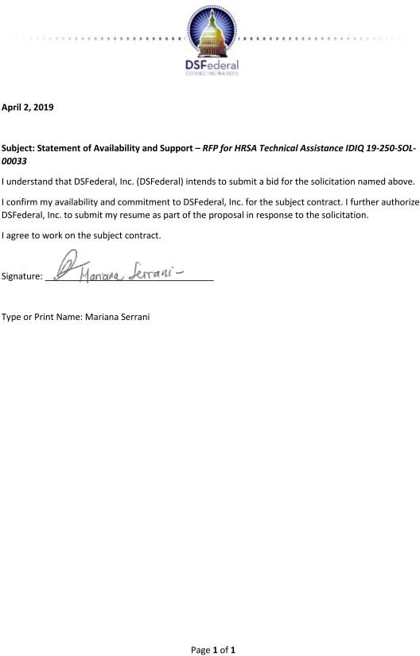

|  |
| --- |
| Qualifications and Experience  Over 20 years of experience in sampling, survey technical assistance, sample yield monitoring, weighting, response rate calculation, control total computation, poststratification, and report writing  Bachelors from Virginia Polytechnic Institute and State University |

1. **Teresa Anne Strickler - Data Administrator / Statistician Summary**

Teresa Strickler is a statistician with 21 years of experience in sampling, survey technical assistance, sample yield monitoring, weighting, response rate calculation, control total computation, poststratification, and report writing.

# Education

B.S., Virginia Polytechnic Institute and State University, 1996

# Relevant Project Experience

*Westat (1997 to Present)*

# Technical Assistance for the Youth Risk Behavior Surveys (YRBS) and the School Health Profile (Profiles)

**Client:** Centers for Disease Control and Prevention (CDC)

Westat provides technical assistance to more than 70 state, territorial, tribal, and local education and health agencies conducting the YRBS and Profiles surveys. Westat’s technical assistance teams consist of a survey operations specialist and a statistician, who help via a toll-free helpline, email, and in-person YRBS training every other year. Ms. Strickler works with sites to create sampling frames and sampling parameters and verifies sample selection. She creates sample coordination charts showing overlap schools between multiple samples, sends sample packages to the sites, and provides technical assistance during survey administration. Ms. Strickler weights the data and creates sampling and weighting descriptions. She also creates weighting specification forms and files for programmers and checks SAS output.

# Phase VI Youth Risk Behavior Surveys (YRBS)

**Client:** Centers for Disease Control and Prevention (CDC)

Westat provided survey technical assistance support to 44 U.S. communities implementing obesity and tobacco prevention programs for adolescents. Westat’s services included designing and selecting scientific samples, modifying and creating YRBS questionnaires, and weighting survey data files. Ms. Strickler was involved in sample selection for the 44 ARRA communities. She provided technical assistance during survey administration, participated in weighting activities, and wrote sampling and weighting descriptions.

**Support for the Tennessee Youth Risk Behavior Survey (YRBS) Client:** East Tennessee State University

**Project Overview:** The 2009-2010 Tennessee YRBS included middle school and high school surveys. Westat selected the two-stage sample (schools and classrooms within schools); scanned answer sheets; weighted middle school data to produce data representative at the district, region, and state levels; analyzed data to estimate 5-year trends and trend variances; and provided consulting support for data analyses and the drafting of technical papers. Ms.

Strickler weighted YRBS data for 10 high school districts and 131 middle school districts and wrote sampling and weighting summaries for each district.

**University of Southern Mississippi Childhood Obesity Study Client:** University of Southern Mississippi

Westat provided statistical services to support the university’s study of childhood obesity in the state. Project staff selected a representative sample of elementary school-aged children and weighted the analytic files used by the university to write final reports. Ms. Strickler weighted data for the 2010 Head Start Study and the 2012 Fitness Study. She worked on sample selection, weighting, and report writing for the 2005, 2009, 2011, 2013, and 2015 Child and Youth Prevalence of Overweight Survey (CAYPOS), a K-12 BMI study. She was also involved in sample selection for the 2017 CAYPOS.

# Pennsylvania Youth Survey (PAYS)

**Client:** Pennsylvania Commission on Crime and Delinquency

PAYS is a biennial school-based survey that collects data on violence, use of weapons, and risk factors associated with delinquent behavior and substance abuse among students in grades 6, 8, 10, and 12. Westat was responsible for questionnaire modifications and printing; sample design, selection, and recruitment; distribution of survey materials; and survey scanning and processing. Ms. Strickler supported the 2005, 2007, and 2009 PAYS by weighting the data by state, region, and stratum. She also calculated response rates and participated in report writing.

**Maine Integrated Youth Health Survey Client:** State of Maine

Working as a subcontractor, Westat is assisting the state in conducting the Maine Integrated Youth Health Survey in grades K and 3, 5, and 6 and in middle schools and high schools.

Westat’s primary role is to draw samples for each survey and to weight the data after survey administration. Ms. Strickler performed weighting adjustments and calculated response rates.

**New England Bladder Cancer Study Client:** National Cancer Institute (NCI)

The objective of this case-control study was to investigate the association between bladder cancer and factors such as occupational and environmental exposures, diet, ethnicity, and genetic factors in residents of three New England states. Westat hired, trained, and supervised the field staff in three states who ascertained new cases of bladder cancer, recruited case and control participants, and scheduled and conducted home visits. Field staff performed CAPI; collected water, urine, blood, toenail, and buccal cell specimens; and obtained GPS measurements. Ms. Strickler evaluated the sampling frames, comparing DMV files to census projections. She documented the coverage of the files for age/sex groups. She also sampled controls from the DMV and CMS frames and computed base weights.

# Teresa Anne Strickler - Statement of Availability

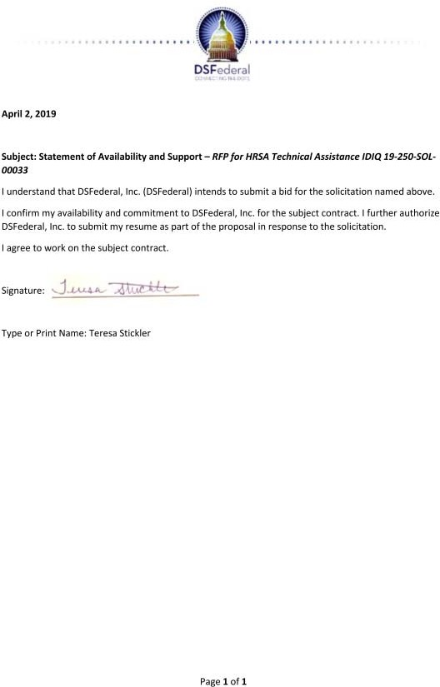

|  |
| --- |
| Qualifications and Experience  Over 10 years of statistical programming for HRSA HAB programs  Bachelors from Princeton University in Linguistics and Statistics |

1. **West Addison – Data Administrator / Statistician**

## Career Summary

Mr. Addison is an owner, Director, and the Chief of Statistical Programming. In this role, he directs and executes complex programming tasks for numerous

projects. He has extensive experience using complex administrative datasets, including child welfare services data, developmental disabilities data, HIV/AIDS data, and Medicare and Medicaid claims data.

## Education, Training, and Certifications

Princeton University, Independent Concentration in Linguistics and Statistics, Princeton, New Jersey, 1984

University of California, Berkeley, Berkeley, California, 1988

## Work Experience

***Lead Statistical Programmer*** 2017–Present

Mission Analytics Group, Inc., San Francisco, CA

*Public Health and Economic Impact of the Ryan White HIV/AIDS Program,* Health Resources and Services Administration (HRSA/HAB)

Subcontract to Mathematica Policy Research, Inc. (MPR)

Mission Analytics is developing and implementing a mathematical model to estimate the life- time costs and benefits of the Ryan White HIV/AIDS Program (RWHAP) model of care compared with those that would result from the elimination of the program. Mission is responsible for leading the analysis of RWHAP Services Report (RSR) data which will be used to understand the population served by the RWHAP, service delivery patterns, and costs associated with the program in conjunction with allocations and expenditures data. Mr. Addison is responsible for developing codes to create outputs from RSR data to operationalize the model.

Statistical Programmer 2017 - Present

Mission Analytics Group, Inc., San Francisco, CA

*Alternative Resource Allocation Methodologies for Ryan White HIV/AIDS Programs Part A & Part C – Phase II,* Health Resources and Services Administration (HRSA HAB)

Subcontract to WRMA, Inc.

Continuing work previously completed under several contracts, this project will support HAB in using Excel tools previously developed by WRMA/Mission Analytics that calculate funding amounts for Ryan White HIV/AIDS Program (RWHAP) Part A supplemental grants and Part C grants. These calculation methods use Centers for Disease Control and Prevention (CDC) surveillance data, publicly available data, RWHAP Services Report (RSR) data, and recipient- level data to standardize the way that funding is allocated, and better align funding with need.

WRMA/Mission Analytics will update the tools with new functionalities and updated data, conduct and analyze runs, and research and report on topics of interest such as the impact of eligible scope reporting requirements on RSR data. Mr. Addison:

* + Creates the RSR output necessary to run the models
  + Assists in as-needed coding activities, such as creating an Excel output on provider service delivery sites and rurality.

Statistical Programmer 2014-2017

Mission Analytics Group, Inc., San Francisco, CA

*Ryan White HIV/AIDS Programs Part A Supplemental Funding – Feasibility Study of Proposed Framework for Allocation of Funds Responsive to Needs****,*** *HIV/AIDS Bureau*, HRSA HAB Subcontracted to Walter R. McDonald & Associates, Inc.

Part A of the Ryan White HIV/AIDS Treatment Extension Act of 2009 provides assistance to eligible metropolitan areas/transitional grant areas (EMAs/TGAs) that are most severely affected by the HIV/AIDS epidemic. In addition to formula funds, HAB funds recipients with Part A supplemental awards on an annual basis. The current method for evaluating need for this supplemental funding involves reviewing and scoring applications submitted by recipients demonstrating the need for additional funding. Historical data related to this process shows that Part A recipients uniformly score within a very limited point range, resulting in proportional funding with little differentiation in regard to absolute need. This project identified for a HRSA/CDC workgroup an empirical, quantifiable framework or formula for awarding supplemental funding to Part A recipient. Mr. Addison was responsible for developing the statistical program.

Lead Statistical Programmer 2015-2017

Mission Analytics Group, Inc., San Francisco, CA

*Evaluation Methods to Award Ryan White HIV/AIDS Program Part C Funds: HIV/AIDS Bureau*, HRSA HAB

Subcontracted to Walter R. McDonald & Associates, Inc.

This project developed a new funding allocation methodology for Ryan White HIV/AIDS Program (RWHAP) Part C grantees to better align funding with grantee performance, costs of care, and service needs. The project included the development of a compendium of factors to potentially include in the model, the testing of three approaches with a sample of grantees to understand impacts on award amounts, and the development of a statistical program and user guide to support HAB with the implementation of the final approach. Mr. Addison was responsible for developing the statistical program.

## Publications and Awards

“Ryan White Services Report (RSR) Client-Level Data: Methodology for De-Duplication,” (with Margaret O’Brien-Strain and Elizabeth Coombs), Report to the HIV/AIDS Bureau, Health Resources and Services Administration, June 2011.

# West Addison - Statement of Availability

|  |
| --- |
| Qualifications and Experience  Over 10 years of experience in project management, training, technical assistance, and strategic planning including over 3 years of recent HRSA HAB and MCHB experience  B.S., Criminal Justice, University of Maryland |

1. **Carly Mensah – Project Manager**

## Career Summary

An accomplished professional with over 10 years of experience in project management and coordination, training and technical assistance coordination and implementation with proven strengths in account management, problem-solving, and strategic planning.

## Education, Training, and Certifications

* B.S., Criminal Justice, University of Maryland, College Park

## Work Experience Project Manager

***DSFederal, Inc., Rockville, MD September 2018 – present***

*Client: Health Resources and Services Administration (HRSA) HIV AIDS Bureau*

* + Manage direct technical assistance through comprehensive site visits to the Health Services and Resources Administration HIV AIDS Bureau grantees.
  + Provide support, extensive coordination and technical/programmatic expertise to the client staff.
  + Develop methods, processes and tools used by various stakeholders throughout the site visit life cycle.

## Project Manager

*Client: Office of Research Integrity (ORI)*

* + Supervise and provide guidance and support to medical and scientific subject matter experts who assist the ORI promote integrity in biomedical and behavioral research.
  + Manage the project budget ($4 million) and ensure on-time submission of reports and contract deliverables.

## Project Manager

***The Bizzell Group, Lanham, MD September 2015 – March 2018***

* + Served as the main point of contact with the HRSA Contract Officer Representative (COR).
  + Provided monthly reports and project deliverables to the COR as required per the SOW.
  + Managed consultants, TA specialists, and the TA coordinator and ensures that deliverables are completed in a timely manner.
  + Met regularly with team members to discuss task progress, technical challenges and examines any potential impact on the planned technical assistance.
  + Met with subcontract leads to assess and reassign tasks as necessary to meet the requirements of the SOW.
  + Assigned financial and programmatic TA consultants to approved site visits.
  + Conducted orientations and ensures the proper onboarding of all consultants.

## Grant Program Manager

***F2 Solutions, Upper Marlboro, MD October 2014 - September 2015***

* + Served as the main point of contact for the Federal Government Program Staff Member at the Office of Head Start (OHS).
  + Managed and coordinated the implementation of grant meetings.
  + Managed the process for grant applications distribution, paneling and archival.
  + Provided guidance through web training to ensure applicants, reviewers, staff members and Federal staff were compliant with regulations and statutory requirements.
  + Reviewed requirements for onsite reviews including paneling, meeting rooms, accommodations, banquet event orders, and registration determined by the client or application reviewers.
  + Reviewed qualifications of new/potential reviewers and made recommendations to the client.
  + Managed expenditures for each peer review.

## Program Manager

***The MayaTech Corporation September 2012 – July 2014***

* + Provided training, technical assistance, and consultation to 53 SAMHSA/Center for Substance Abuse Treatment (CSAT)-funded grantees.
  + Coordinated over 40 individual training and technical assistance requests.
  + Designed and developed 26 training webinars for nearly 2,350 participants.
  + Initiated and prepared continuing education units’ packages to include certificates for dissemination to participants.
  + Advised management on the development of training activities to assist their organizations in meeting program requirements.
  + Facilitated consultative site visits for 20 grantee organizations to assess training needs and organizational capacity and provide recommendations.
  + Recruited and engaged over 35 consultants to provide subject matter expertise to grantee organizations.

## Grant Program Manager

***Lux Consulting Group, Inc. - Silver Spring, MD August 2009-September 2012***

* + Served as the main contact and support for the Federal Government Program Staff Member at the Administration for Youth and Family Services (ACYF).
  + Managed and coordinated the implementation of 32 grant meetings.
  + Developed project management plan to guide project performance and functional activities.
  + Provided guidance through web training to ensure applicants, reviewers, staff members and Federal staff were compliant with regulations and statutory requirements.

## Program Coordinator

***The MayaTech Corporation - Silver Spring, MD May 2007- August 2009***

* + Served as the client liaison to provide on-site training logistical management and support for the Substance Abuse and Mental Health Services Administration, Rapid HIV Testing Initiative.
  + Planned state training events and managed the registration process for up to 2,000 over 28 organizations.

|  |
| --- |
| Qualifications and Experience  Over 30 years of experience developing digital multimedia projects including two HRSA MCHB websites  Bachelor of Fine Arts from the University of Florida, Gainesville  Produced award-winning documentaries |

# Gregory Randal Miller – Training Specialist

## Career Summary

Gregory Randal Miller has 30 years of experience developing digital multimedia projects, including videos, websites, and e-Learning. He is experienced in managing complex projects from start to finish and managing client relationships, serving as a liaison between the client and technical teams. He has extensive experience with video, audio, graphics, website, instructional design, and database management. He has created several award-winning documentary videos and designed graphics for print and

the Web. His clients include universities, government agencies, and public health and environmental organizations.

## Education, Training, and Certifications

* Bachelor of Fine Arts, University of Florida, Gainesville (1989)

## Work Experience

Multimedia Developer October 2012 – Present Independent/Self-Employed, Gainesville, FL

Social Solutions International (fulfilling contract work for the federal Maternal and Child Health Bureau); Axis Group, LLC; University of South Florida (Florida Health and Transition Services); Family Café Technical Assistance Center

* Services include project management, web design and development, graphic design, instructional design, video production, print publications, and technical assistance.

Educational Media Coordinator April 1999 – October 2012 Institute for Child Health Policy, University of Florida, Gainesville, FL

* Developed and produced educational and instructional multimedia in support of the Maternal and Child Health community. Developed video programs including script-writing, videography, editing and production management. Developed interactive multimedia, including web sites, listservs, web conferencing and project collaboration. Provided technical support for electronic media including computer hardware and software.

Camera Assistant Spanish Translator July 1995 – June 1998 Outland Films, Gainesville, FL

* Wildlife camera crew for television documentaries for Discovery Channel, National Geographic, PBS, TV New Zealand, Partridge Films, Wild Visuals, ABC Australia, and others

Video Production Coordinator November 1994 – September 1996 Center for Aquatic Plants, University of Florida, Gainesville, FL

* Script-writing, videography, editing and production, and studio management

Adjunct Faculty September 1994 – September 1996 Santa Fe College, Gainesville, FL

* Teaching documentary video production tools and techniques

Video Producer July 1990 – November 1994

Independent/Self-Employed, Gainesville, FL

* Clients included: St. Johns River Water Management District, Alachua Conservation Trust, and Center for Governmental Responsibility, University of Florida

Video Producer June 1989 – September 1994

Researching the Arts in Multimedia, Gainesville, FL

* Script writing, camera and post-production

## Video Programs

* My Health Care: Instructor Training Guide (Run time: 64 minutes; 2013, 2014, 2015)
* My Health Care: Curriculum Video Clips (Several short video clips; 2014, 2015)
* Welcome to Shands Children’s Hospital (Run time: 10 minutes; 2012)
* Adult CF Clinic Tour at Shands, UF (14:47 mins; 2011)
* Talking with Your Doctor (Run time: 18 minutes; 2008)
* This Is Health Care Transition (Run time: 29 minutes; 2007)
* Health & Ready to Work (Run time: 2.5 minutes; 2007)
* Health Care Transition: College and Beyond (Run time: 24 minutes; 2004)
* Health Care Transition: Jim's Story (Run time: 10 minutes; 2001)
* One Heart, Many Voices (Run time: 7 minutes; 2002)

# Gregory Randal Miller - Statement of Availability

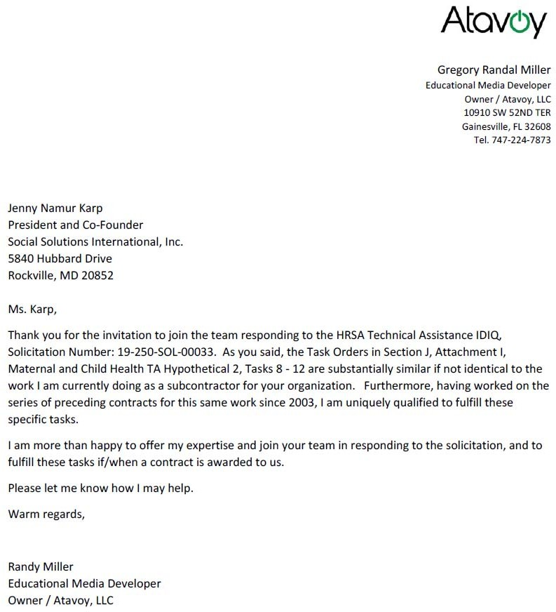

|  |
| --- |
| Qualifications and Experience  Over 20 years of software development experience  B.S.E.E. Computer Engineering, Virginia Tech, Blacksburg, VA 24061, 1996  Sun Certified Programmer for the Java 2 Platform, Prometric, 2000  PMP Certified, Prometric, 2014 |

1. **Ming Chan - Information Management Specialist**

## Career Summary

20+ years of software development experience, practical experience in project management, with strong ability of client communication, project management, process optimization and team building, stimulate team members’ enthusiasm and confidence.

Focus on the overall situation of the company, with market focus and strategic vision, and have an insight into the development and strategic planning of the company. An excellent team leader and player, with experience in team management, optimization, target

management and personnel evaluation. An excellent coordinator in the project. Excellent at problems solving, costs control, and risk control.

Project experience on various contracts for different Federal clients including the Food and Drug Administration (FDA), the Centers For Medicare/Medicaid (CMS) ,the Department of Health and Human Services (HHS), the Department of Transportation (DOT), the Department of Justice (DOJ), the United States Postal Service (USPS), the U.S. Department of Agriculture (USDA), the Department of Labor (DOL), the U.S. Consumer Product Safety Commission (CPSC), and the Department of Defense (DOD)

## Education, Training, and Certifications

* B.S.E.E. Computer Engineering, Virginia Tech, Blacksburg, VA 24061, 1996
* Sun Certified Programmer for the Java 2 Platform, Prometric, 2000
* PMP Certified, Prometric, 2014

## Work Experience

**DSFederal, Inc., February 2013 – Present Director of IT Services**

* **Technical Guidance:** Lead team to support the integration of in-house applications including SharePoint, Office 365, Appian BPM, Amazon AWS.
* **Client Relationship:** Establish a good cooperative relationship between the company and the client, improve the client’s satisfaction, promote the second or third sales opportunities, and increase the client's loyalty.
* **Team Management:** Lead 30 team members, be responsible for personnel recruitment, established guidance system, set target and KPI, standardized the work flow.

# Client: US Army Research Laboratory (ARL) Technical Project Manager

* Manage projects execution, monitor projects performance, manage budget, and control scope.
* Create IT Strategic plan and provide leadership in executing the plan
* Continuously working with key stakeholders on vision, directions, and IT strategy
* Interact with Project Leads, architects, and Development & infrastructure teams to define and deliver

business solutions.

* Provide overall management to multiple teams implement process automation, system modernization, new system development, QA.
* Review enterprise architectures and discuss overall strategy with the technical leads and architects.
* Provide design on system integrations and system interoperability
* Provide Leadership and Mentoring to technical leads and team leads

# Client: Centers for Medicare & Medicaid Services (CMS) Technical Project Manager

* Manage project execution, monitor project performance, manage budget, and control scope.
* Developed and maintained CA Clarity PPM.
* Upgraded CA PPM from 14.3 to 15.2
* Lead effort to migrate CA PPM from Windows 2008 to Windows 2012 R2
* Worked with customers to develop Budget Execution workflow in CA PPM

# Client: Consumer Product Safety Commission (CPSC) Solution Architect

* Architected CPSC product safety system using Hadoop Ecosystem.
* Designed and implemented product safety system utilizing HDFS, MapReduce, Hive, Oozie, Spark, Sqoop and YARN.
* Hands on experience using Cloudera and Hortonworks distributions.

# Client: FDA, Rockville, MD CA PPM Architect

* Developed and maintained CA Clarity PPM.
* Customized project module and budget module to adhere to HHS EPLC and FDA policy.
* Worked and guided customers throughout the process of customizing the project module and budget module to meet business requirements following SCRUM

# Powertek Corporation, August 2012 – February 2013 Technical Team Lead

**Client: Department of Labor (DOL)**

* Served as the senior technical expert and lead multiple software development projects and web / application development teams.
* Mentored team members in the use of web technologies and development techniques including Object Oriented design, Java/J2EE, .NET, PHP, Drupal, Document Management System (DMS), XML/XSLT, Struts 2, DB2 and SQL.
* Met regularly with customers to discuss change requests, report project status, brief project progress.

|  |
| --- |
| Qualifications and Experience  Over 15 years of technical assistance including as Project Director of two HRSA MCHB Projects  Master’s in Public Health specializing in Maternal and Child Health from The George Washington University |

# Jenny Namur Karp – Training Specialist

## Career Summary

As the President and Co-Founder of Social Solutions, Ms. Namur Karp brings over 15 years of corporate leadership, experience, and perspective at the Vice President, Senior Vice President, or President level to the HRSA MCHB project. Her corporate management experience, coupled with her technical background in Maternal and Child Health (MCH), give her the skills and expertise necessary to provide value to this

contract. She manages staff and subcontractors, monitors budgets and assures contract performance and compliance toward the overarching goal of customer satisfaction. She has served as Corporate Monitor (CM) or PD on more than 50 federally funded projects and has directed, designed, and implemented training and TA and evaluation projects in two-dozen countries across four continents. Her career spans over 15 years of technical and corporate experience. She has worked extensively with HRSA, HHS, USAID and the US Departments of State (DoS). Highlights include serving as the Project Director for two HRSA projects, one addressed the intersection between intimate partner violence (IPV) and perinatal depression (PD) and one assisted HRSA with the development, translation, adaptation, revision, and updating of the various domains in the Bright Futures for Women’s Health and Wellness educational materials. Ms. Namur Karp was also the PD on an evaluation of the United States Air Force’s Sexual Assault Prevention Program and an environmental scan for DHHS’ Office on Women’s Health (OWH) to inform the development of a National Girl Health campaign. She served as Project Director of an OWH project to train HIV service providers on IPV and CDC funded project to educate women of childbearing age about the risks of STDs on pregnancy and pregnancy related outcomes. In her technical skills, she has more than 15 years in the management of maternal and child health promotion and disease prevention projects ranging from outreach, education, and counseling to program development, implementation, and evaluation. Her research and practical experience focus on the prevention of violence against women, STDs, HIV. Ms. Namur Karp also has extensive experience developing and implementing training and technical assistance for a broad range of audiences include MCH, intimate partner violence, mental health and substance abuse care providers. Ms. Namur Karp has degrees in Early Childhood Education and Child Development from Vanderbilt University and a Master’s in Public Health specializing in Maternal and Child Health from The George Washington University.

## Education, Training, and Certifications

* George Washington University, Master of Public Health, Maternal and Child Health, Washington, DC, 2001
* Vanderbilt University, Bachelor of Science, Education / Child Development, Nashville, TN, 1998

## Work Experience

President 2012 – Present

Senior Vice President 2010 – 2012

Vice President 2006 – 2010

Director, Health and Gender Research 2005 – 2006

Social Solutions International, Rockville, MD Select Projects:

Bright Futures Emotional Wellness Tools: HRSA, Office of Women’s Health

State and Community Resource Development to Prevent, Assess, and Provide Interventions Addressing Intimate Partner Violence and Perinatal Depression: HRSA MCHB

State and Community Resource Development to Prevent, Assess, and Provide Interventions Addressing Intimate Partner Violence and Perinatal Depression: HRSA, MCHB

* Direct all projects and tasks related to international and domestic public health
* Monitor project budgets and organizational growth; staff coverage
* Supervise, manage, and mentor doctoral, master’s, and bachelor’s level staff
* Responsible for the day-to-day management of project and organizational operations
* Provide support and guidance to health research design, implementation, evaluation and management
* Design, implement, evaluate and supervise various public health promotion programs
* Serve as Project Director/Investigator on government and private grants, contracts, and research
* Develop, implement, and evaluate health and gender specific curriculum, training, and other educational materials

Area Manager, Sexual & Reproductive Health 2004 – 2005

Project Director and Research Associate 2001 – 2004

Danya International, Inc., Silver Spring, MD

* Managed all tasks related to area research, programs, and operations
* Ensured all area project goals are successfully achieved
* Provided support & guidance to area project’s design, implementation, evaluation & management
* Designed, implemented, evaluated, and managed various public health promotion programs
* Managed and directed mid-size to large government grants, contracts, and projects
* Developed and evaluated health curriculum, training, and other educational materials
* Facilitated evaluation activities, focus groups, pilot tests; analyzed data

Graduate Intern 2000 – 2001

Center for Woman Policy Studies, Washington, DC

* Researched, wrote, and designed HIV/AIDS Policy Update for State Health Officials
* Researched and wrote, edited and analyzed policy statements, white papers, testimony re: HIV
* Organizational representative at Congressional and Senate Hearings
* Liaison to Regional and National Health Organizations
* Report,” Report to HRSA, January 2010.

# Jenny Namur Karp - Statement of Availability

|  |
| --- |
| Qualifications and Experience  Over 20 years of travel and logistics experience including current work on HRSA MCHB and HAB Programs  Pennsylvania State University, State College, PA – Aerospace Engineering  Certified Meeting Planner (CMP) since 2001 |

1. **Mary Neyhard – Travel Coordinator**

## Career Summary

Over 20 years of experience as a meeting and travel manager coordinating complex travel arrangements both domestic and international.

## Education, Training, and Certifications

* Pennsylvania State University, State College, PA – Aerospace Engineering (3 yrs.)
* Certified Meeting Planner (CMP) since 2001
* Dale Carnegie Leadership Training
* Toastmasters Competent Leadership (CL) and Competent Communicator (CL)

## Work Experience

Travel Coordinator, Project Manager November 2017 – Present DSFederal, Rockville, MD

Projects: HRSA HAB Building Futures - Supporting Youth Living with AIDS, HRSA G-TAP project

* Coordinated Travel for Consultants to Africa including Airfare, Hotel and Ground Transportation following the Federal Travel Regulations (FTR) issued through GSA.
* Participated in pre-planning calls with clients to ensure all details were covered and the consultants felt prepared for the travel portion of their trip.
* Coordinated International Travel & Health Emergency Insurance, Passports/VISAS, International Cell Phone Coverage, Inoculations (provided list) and provided Emergency Phone Numbers for Consultants while overseas.
* Coordinated Domestic Travel keeping costs low by negotiating hotel rates at or below government per diem. Saved $15k in travel costs in 2018.
* Coordinated Pre-Payment with Hotels to minimize expenses for consultants on their personal credit cards. Former Hilton Hotel Director who understands hotels and their internal systems.
* Compiled detailed trip logistics for consultants prior to their departure. Founder, Meeting Planner

Cuz Events, LLC

October 2016 – November 2017

* Workshop Director for Service Corps of Retired Executives (SCORE) under the Small Business Administration umbrella.
* Expanded the SCORE Program from 2 locations to 14 locations across the DC Metro Area – without costing them any additional dollars.
* Developed a relationship between the Hillman Entrepreneurial Program at Montgomery County Community College and SCORE volunteers.
* Coordinated a one-day conference/luncheon for 1500 attendees for Housing Association of Nonprofit Developers (HAND) at the Omni Hotel in Washington, DC.

Meeting Planner, Philanthropic Lead December 2013 – October 2016 Lockheed Martin IS&GS, Gaithersburg, MD

Projects: USA Science and Engineering Festival, Washington, D.C. Convention Center, Lockheed Martin Excellence Awards, A Million Makes a Difference Campaign,

Walter Reed Hospital Volunteer Campaigns (various)

* Saved Lockheed Martin $250k in costs in 2014 using my expertise to coordinate the Excellence Awards
* Coordinated Air, Hotel and Ground Transportation for Award Winners and Executive Off- site meetings.
* Planning leader for 17 consecutive events commemorating the merger of Lockheed Martin IS&GS with Leidos.

Meeting Planner October 2011 – December 2013 CACI International, Arlington, VA

Projects: Mergers and Acquisitions (announcement events), CACI Excellence Awards, CACI Board Meetings with Dr. London (Board Chair)

* Saved CACI International $50k in costs in 2012 using my expertise to negotiate the venue expenses for the CACI Excellence Awards
* Coordinated Air, Hotel and Ground Transportation for Events.

## Awards

* Lockheed Martin Corporate Communications Comet Award - 2014.
* Lockheed Martin SRA Award – 2014, 2015
* PRSA Silver Anvil Award - 2015
* President Volunteer Award – 2013, 2014, 2015

|  |
| --- |
| Qualifications and Experience  Over 17 years of experience working across Bureaus and offices including MCHB and HAB  Graduate Certificate Program, Health Care Quality, the George Washington University School of Medicine and Health Sciences (coursework completed; certificate pending)  Director’s Award from HRSA MCHB 2007 |

# Stefani Olsen – Project Manager

## Career Summary

Ms. Olsen is a certified Project Management Professional (PMP) whose most recent 17 years of work have focused on leading projects in support of HRSA, including technical assistance and systems development projects. These efforts have included support for the collection and analysis of HRSA data, including performance and outcome measure data, health indicator data, demographic and program service and financial data. Ms. Olsen combines IT Project Management expertise with knowledge of public and clinical health; her domain expertise includes maternal

and child health, HIV/AIDS, rural health, and health professions. Under the HRSA TA contract with DSFederal, Ms. Olsen lead teams providing global technical assistance for the HIV/AIDS Bureau and providing support to the redesign of the National Survey of Children’s Health.

Previously, Ms. Olsen led development of the first Web-based Title V Information System (TVIS) and Discretionary Grants Information System (DGIS) for MCHB; she lead development of the HIV/AIDS Bureau’s first client-level data collection system (the Ryan White Services Reporting System (RSR)) as well as the AIDS Drug Assistance Program (ADAP) Data Report (ADR). She led the development of a client-level data collection system for the HRSA Healthy Start program, facilitating the collection of de-identified client record data for calculation of benchmarks and measures.

## Education, Training, and Certifications

* Graduate Certificate Program, Health Care Quality, the George Washington University School of Medicine and Health Sciences (coursework completed; certificate pending)
* Project Management Professional, Project Management International, 2007 – Present
* Bachelor of Arts, Journalism, The George Washington University, Washington, D.C., 1987

## Work Experience

**Project Manager, HRSA National Practitioner Data Bank DSFederal, Rockville, MD February 2019 - Present**

Ms. Olsen leads the project team conducting a three-phased analysis of HRSA’s Bureau of Health Workforce (BHW) National Practitioner Data Bank (NPDB) program and system.

# Program Manager, Comprehensive System and Organizational Assessment of the HRSA National Practitioner Data Bank (NPDB)

**DSFederal, Rockville, MD March 2018 – September 2018**

Ms. Olsen served as the Program Manager for DSFederal’s Next Generation IT Services (NGITS) contract, supporting the HHS Office of the Chief Information Officer (OCIO). This contract supports OCIO’s Information Technology and Infrastructure Operations (ITIO).

# Vice President, IT Services May 2017 – February 2018

**DSFederal, Rockville, MD**

As VP of IT Services Ms. Olsen oversaw delivery of approximately $7 million of work annually, with 5 directors and a staff of over 40 IT professionals.

# HRSA Program Manager April 2016 – April 2017 DSFederal, Rockville, MD

Ms. Olsen served as Program Manager of all DSFederal’s HRSA projects. She served as project manager for the following task orders under the HRSA Technical Assistance contract: Support for the redesign of the National Survey of Children’s Health (NSCH); technical assistance provided under the HAB Global Technical Assistance Program (GTAP) task order. She also managed a custom software systems development effort for the Health Start program. Ms. Olsen provided subject matter expertise including performance measurement tool development and data analysis to serve program goals and needs.

# Director of Health Programs September 2013 – March 2016 DSFederal, Rockville, MD

Ms. Olsen oversaw DSFederal contracts with the National Institutes of Health (NIH), the Office of the National Coordinator (ONC), and the Administration for Children and Families (ACF).

# Customer Relationship Manager February 2013 – August 2013 SAIC, Rockville, MD

Conducted satisfaction discussions and follow up with HRSA customers including the Maternal and Child Health Bureau, HIV/AIDS Bureau, Office of Rural Health Policy, and Office of Information Technology.

# Program Manager February 2002 – January 2013 SAIC, Rockville, MD

For the Bureau Reporting Systems (BRS) contract (September 2011-January 2013), Ms. Olsen served as the contractor’s (SAIC’s) Program Manager of software development and maintenance efforts for four HRSA Bureaus (the HIV/AIDS Bureau, the Maternal and Child Health Bureau, the Office of Rural Health Policy, and the Bureau of Health Professions).

## Publications and Awards

* Director’s Award, Health Resources and Services Administration (HRSA) Maternal and Child Health Bureau (MCHB), “In recognition of contributions made to the health of infants, mothers, children, adolescents and children with special health needs in the Nation,” 2007.

|  |
| --- |
| Qualifications and Experience  Over two years of experience supporting HHS Operating Divisions including HRSA  B.A., English, summa cum laude  DSFederal Employee of the Year, 2017 |

# Claire Pak - Writer/Editor

Claire Pak is a writer and editor with several years of experience supporting federal agencies. She currently serves as Communications Manager for the HHS Next Generation IT Services (NGITS) Program Management and Integration task order. Ms. Pak is a writer/editor whose experience includes policy and procedure writing, proposal writing and editing, writing and editing a variety of content for internal and customer use, and social media management. She specializes in

distilling complex business and technical ideas into simple, plain language; and is an effective editor, skilled at polishing the work of other authors.

## Education, Training, and Certifications

* University of Maryland University College, B.A., English *(summa cum laude)*

## Work Experience

Communications Manager/Technical Writer January 2017 - present DSFederal, Inc., Rockville, MD

* + Communications Manager for the HHS Office of the CIO Next Generation IT Services (NGITS) program (since March 2018). Write and edit management reports and news updates, develop and deliver presentations, facilitate meetings that include government stakeholders at all organizational levels, contribute to SharePoint redesign project; and provide writing, editing, and proofreading support for the entire team.
  + Write, edit, and proofread proposals, capability statements, RFI responses, cut sheets, and other business development materials and collateral.
  + Write web content, including blog posts.
  + Contribute to internal communication (write and edit monthly newsletters, write and edit internal memos, and work with project managers to communicate project information).
  + Manage company social media accounts.
  + Provide writing and editing support for customers including HIV/AIDS Bureau (HAB) Building Futures program, HRSA Office of Federal Assistance Management (OFAM), HIV/AIDS Bureau Global Technical Assistance Program (G-TAP), Office of Research Integrity (ORI), Assistant Secretary for Preparedness and Response (ASPR), Office of the National Coordinator for Health Information Technology (ONC), and others.
  + Provide as-needed corporate writing and editing assistance, including white papers, executive correspondence, employee resumes, memos, etc.

Technical Writer/Talent Acquisition Support Specialist March 2016 – January 2017 MasterPeace Solutions, Ltd., Columbia, MD

* + Supported talent acquisition and placement for a small NSA technical subcontractor.
  + Interviewed software and system engineers; wrote and edited resumes.
  + Wrote and edited submissions to prime contractors.
  + Assisted with corporate and marketing communications.

Copy/Content Editor November 2014 – March 2016 Frontier Strategy Group, Washington, DC

* + Provided copy/content editing support for a business advisory services firm. Edited subscription reports and custom research reports commissioned by corporate clients.
  + Topics included business, economic, and political conditions in WEUR (Western Europe), LATAM (Latin America), CEE (Central and Eastern Europe), MENA (Middle East and Northern Africa), SSA (Sub-Saharan Africa), APAC (Asia Pacific and China).
  + Work included both simple line-level edits for spelling, punctuation, and basic grammar; and deeper, content-level edits to improve cohesion, clarity, and concision. Many of the company’s researcher/authors are non-native writers of English.
  + Wrote corporate style guide.

Senior Technical Recruiter January 2014 – October 2014 Pontoon Solutions/The SI Organization, Laurel MD

* + Same as below—Applied Communication Sciences was acquired in May 2013 by The SI Organization, and The SI Organization outsourced recruitment to Pontoon Solutions.

Technical Recruiter/Staffing Specialist September 2012 – December 2013 Applied Communication Sciences, Basking Ridge, NJ

* + All aspects of recruiting and staffing for a telecommunications and computer science research company with substantial Federal contracts, including campus recruiting.
  + Recognized by company CEO for improvements in process and service.

Technical Recruiter/HR Generalist September 2009 – June 2012 Government Services IPT, Largo, MD

* + All aspects of recruiting/staffing for SBA-certified 8(a) contractor across multiple technical disciplines. Played significant role in company growth, from approximately 75 employees in 2009 to approximately 120 at peak in 2010.
  + Wrote/edited the company’s online Employee Handbook and Operations Manual.
  + Served as a technical writer on project teams. Wrote newsletter articles for military clients and drafted and edited policy/procedure manuals for civilian and military clients.

Montgomery County Examiner/EXAMINER.COM (Freelance Writer) April 2009 – June 2009 EXAMINER.COM (Clarity Digital Media)

* + Generated story ideas, conducted interviews, took photographs, and wrote articles.

## Awards/Honors

* DSFederal Employee of the Year, 2017
* Phi Kappa Phi National Honor Society

|  |
| --- |
| Qualifications and Experience  Over 30 years of Data Architecture and information systems design  BS Chemical Engineering, Imperial College, London |

# Nigel Shaw - Data Architect

## Career Summary

Systems architecture, analysis and design, database analysis, modeling, design, configuration, tuning, deployment for data warehouses and enterprise-class client-server, multi-tier database applications using Netezza, Hive, Oracle and SQL Server. Expert for Netezza design and performance tuning. Specializes in design of databases and systems managing large

volumes of data, also an expert in tuning existing databases/data models and porting data warehouses from traditional RDBMS to distributed database. Experienced designer and developer of advanced analytics for real time systems and for BI reporting. A leader for enterprise data management with the passion to create extraordinary solutions while still dedicated to taking care of the thousands of details required to build a complete data management solution.

## Education, Training, and Certifications

BS Chemical Engineering Part 1, Imperial College, London 1977

## Work Experience

***Solutions Architect January 2018 – Present***

*DSFederal, Inc., Rockville, MD*

* + Data Architecture oversight for DSFederal
  + Database SME for Relational Databases, Big Data and Blockchain
  + Solution designer for enterprise class databases
  + Developer of database best practices
  + Manages DSFederal Innovation Council

## Big Data Architect December 2012 – January 2018

*Aginity*

* + Provided technical leadership for migration of a financial data warehouse to a new distributed model on Netezza.
  + Mentored developers and data modelers for Netezza physical design and Netezza best practices

## Database Architect March 2001 – December 2012

*Cricket Communications, Inc.*

* + Provided technical leadership for architecture, design and development of a new Oracle data warehouse at Cricket.
  + Provided architecture and design for back-end systems using Oracle 10G, Informatica, Oracle PLSQL to support both revenue calculation and revenue reporting for systems requiring data management support.

## Senior Database Engineer July 2000 – December 2000

*Spotcast Communications, Inc.*

* + Provided technical expertise and project management for design, development, management and operation of a data warehouse for cellular call flow data.
  + Extensive optimization was performed to ensure timeliness of the data delivery, and optimized performance of the web queries.

## Technical Manager July 1999 – June 2000

*Expert Choice, Inc.*

* + Provided technical leadership and project management for design, development, management and operation of a financial data warehouse at the CAMS (Commerce Administrative Systems) Support Center for the Commerce Department (DOC).
  + Software developed included: ETL (Extract-Transform-Load), infrastructure (ETL/background job manager) and data warehouse client software. Extensive performance analysis and server/instance/application/SQL tuning ensured the optimized performance of both the database and the warehouse applications.

|  |
| --- |
| Qualifications and Experience  Over nine years of training, coaching, and curriculum development experience  CDC Institute for HIV Prevention Leadership Fellow  Specialized coaching, outreach, and counseling training |

# Adam Thompson – Training Specialist

Adam Thompson is a seasoned training specialist and consultant with specialized experience and training in HIV/AIDS education. A proven coalition builder and problem solver, he excels at community engagement and program management and development. Mr. Thompson’s experience includes training, coaching, capacity building, and systems management and improvement. He has conducted and developed training for government, community, educational, and religious organizations.

## Education, Training, and Certifications

* + University of Buffalo, Millard Fillmore College, Buffalo, NY. Certificate in Practice Facilitation, 2015
  + Georgetown University, Washington, DC. B.A., Theology/Christian Ethics, 2010
  + Fellow, Institute for HIV Prevention Leadership, CDC, Atlanta, GA, 2008
  + Effective Behavioral Interventions (EBI)
    - Mpowerment – Academy for Educational Development (AED)
    - Healthy Relationships – Center for Health and Behavioral Training (CHBT)
    - Community P.R.O.M.I.S.E. – Center for Health and Behavioral Training (CHBT)
  + Core Strategies for Street Outreach – Virginia Department of Health (VDH)
  + Creating Lasting Family Connections Implementation Trainer – COPES Louisville, KY
  + Training of Trainers (TOT), Training of Quality Leaders (TQL), Training of Coaching Basics (TCB) – National Quality Center
  + Fundamentals of HIV Prevention Counseling, CDC

## Work Experience

Regional Partner Director 2014 – present

NE Caribbean AIDS Education and Training Center South Jersey Regional Partner

* + Serve as local provider resource on delivery of HIV prevention, care, and treatment.
  + Designed and co-developed state-wide network of Community Health Workers.
  + Co-direct a multi-year, statewide integration project aimed at improving access and systems-levels outcomes for behavioral health services.
  + Support ongoing practice transformation projects to improve community and patient health outcomes.
  + Serve on national technical expert panels and advisory bodies.

Consultant 2008 – present

Center for Quality Improvement and Innovation, National Quality Forum, Virginia

* + Contracted by over 20 governmental (federal and state), clinical, nonprofit and religious organizations.
  + Coordinated multi-year youth behavioral intervention for at-risk youth in Richmond City public schools.
  + Enhanced federal grantee system design and care delivery through coaching and TA.
  + Managed community aspect of national quality campaign improving patient linkage and retention rates.
  + Revised nine Family Life Education professional development modules for Virginia Department of Education.

Manager – Prevention, Education, Testing 2006 – 2010

AIDS/HIV Services Group

* + Managed implementation of evidence-based behavioral interventions.
  + Developed and implemented a successful quality management program for clinical screening services.
  + Created policy and procedure manuals for all grant-funded activities.
  + Successfully secured over $500,000 in annual government grant funding.

## Publications

Fox, T., Hager, M., Thompson, A., Van Alst, D., (2017). *Getting to zero: Global social work responds to HIV: Chapter Ten The Many Roles of the Social Worker in Shaping the Quality of Care in Transdisciplinary Teams as We Get to Zero*. Geneva: UNAIDS and IASSW.

DeLorenzo, L., Dino, M., Hager, M., Hurley, B., Jimenez, T., McKinnon, K., Thompson, A. (2018). *New Jersey Leads on Trauma and Behavioral Health Through Two New Initiatives*. New Jersey HIVLinks, Spring 2018, 2-4.

## Committees and Affiliations

* + 2018 Co-Chair, National Quality Forum Chronic Disease and Primary Care Standing Committee
  + 2018 Member, Board of Directors, National Quality Forum
  + 2017 Co-Chair, National Quality Forum Infectious Disease Measurement Endorsement Standing Committee
  + 2016 Keynote Speaker, National Sexual Education Conference
  + 2012 Member, National Quality Forum, Infectious Disease Measure Endorsement Committee
  + 2010 Recipient, Quality of Care Leadership Award – HRSA HIV/AIDS Bureau & National Quality Center

## Curricula Developed

* + *NQC Training of Consumers on Quality: Facilitator Manual to Build Capacity of People Living with HIV to Actively Participate in Quality Improvement Activities (2014).* Developed by the New York State Department of Health AIDS Institute National Quality Center. Funded through a cooperative agreement with the Health Resources and Services Administration HIV/AIDS Bureau.
  + *Building Leaders of Color (BLOC) Facilitator Manual to Build the Capacity of Transgender Women of Color Living with HIV for Leadership Positions (2017).* Developed by the National Minority AIDS Council. Funded through a cooperative agreement with the Health Resources and Services Administration HIV/AIDS Bureau.
  + *Building Leaders of Color (BLOC) Facilitator Manual to Build the Capacity of Persons of Color Living with HIV for Leadership Positions (2017).* Developed by the National Minority AIDS Council. Funded through a cooperative agreement with the Health Resources and Services Administration HIV/AIDS Bureau.

# Adam Thompson - Statement of Availability

|  |
| --- |
| Qualifications and Experience  More than eight years of experience managing and coordinating public health programs, including five years managing HRSA MCHB Programs and three years supporting HAB.  Master of Science in in Public Health (MSPH) with an International Health concentration  For MCHB, managed system development, testing, deployment, operation and maintenance and end-user support; and led communication and outreach with HRSA stakeholders and grantees. |

1. **Echo Wang, M.S.P.H. – Project Manager**

## Career Summary

Ms. Echo Wang is an experienced professional that manages/leads various public health projects. She has 8+ years of progressive experience in data and business analysis, public health research and program evaluation and monitoring, and project management. Ms. Wang’s subject matter areas include maternal and child health, HIV/AIDS, federal health services grants, and health informatics.

## Education, Training, and Certifications

* Doctor in Public Health (DrPH), Health Policy and Management (Concentration: Public Health Informatics), Johns Hopkins School of Public Health (JHSPH), Baltimore, MD, 2017 – present
* Certificate in Biostatistics (Master’s level), Georgetown University, 2016
* Master of Science in Public Health (MSPH), International Health, JHSPH, Baltimore, MD, 2012
* B.S., Food Science, University of Maryland, College Park, MD, 2006-2010

## Work Experience

Project Manager, DSFederal, Inc. Aug 2018 – Present

* Managed a technical assistance project ($7 million budget) to coordinate and deliver onsite compliance review for the Home Visiting program by providing programmatic and financial subject matter expertise.
* Developed and streamlined the methods, processes and tools used by various stakeholders during the pre-visit, onsite and post-visit phases, to ensure quality, consistency, efficiency and transparency throughout the site visit life cycle.

Project Manager/Principle Investigator Sept 2017 – Present DSFederal, Inc, Rockville, MD

Office of Federal Assistance Management, Health Resources and Services Administration

* Led a risk management study by applying the Enterprise Risk Management (ERM) methodology for the grant management processes in HRSA.
* Conducted stakeholder interviews, business process analysis, industry best practice research, and data indicator development to identify risks and opportunities throughout the business process.
* Developed a semi-automatic risk assessment tool including risk profile, opportunity register, risk dashboard that allow for continuous risk monitoring and management.

Project Manager (former Senior Analyst) June 2014 – Present DSFederal, Inc, Rockville, MD

Maternal and Child Health Bureau, Health Resources and Services Administration

* Analyzed the business and system requirements of Healthy Start program’s client-level data reporting system; led testing activities (e.g. test cases, internal and user acceptance testing); developed user training and instructional materials, supported technical assistance efforts, and prepared documentations following Agile and CMMI III standard procedures.
* Developed algorisms and layouts to calculate and present benchmarks and performance measures in dashboard and ad-hoc reports (in Pentaho) to allow real-time program monitoring.
* Managed system development, testing, deployment, operation & maintenance and end-user support; and led communication and outreach with HRSA stakeholders and grantees.

Sr. Research Analyst Jan 2016– Present

DSFederal, Inc, Rockville, MD

HIV/AIDS Bureau, Health Resources and Services Administration

* Organized and conducted site visits to Ryan White HIV/AIDS program funded providers to understand best practices and barriers to providing care to youth living with HIV.
* Conducted and analyzed interviews with clinic’s management, staff and youth clients to assess factors contributing to the clinical and quality outcomes.
* Developed technical assistance tool kit and coordinated an implementation pilot with clinical providers to create a practical, evidence-based toolkit for all Ryan White providers.
* Presented best practices and toolkit implementation results to HAB managers and RWHAP providers.

Senior Research Assistant & Project Coordinator Aug 2012 – May 2014 Georgetown University Medical Center, Georgetown, Washington, DC

Cancer Control Program, Lombardi Comprehensive Cancer Center

* Developed and implemented clinical trials, surveys and behavioral studies focusing on prevention, early detection, and management of various cancers.
* Managed and analyzed questionnaires, recruitment, process evaluation and national registry data for peer-reviewed publication using quantitative and qualitative methods (e.g. SAS, SPSS, Access database, Redcap).
* Designed surveys following psychometric standards, conducted systematic literature reviews, established collaborations with community leaders, and assisted with other proposal development tasks.

## Publications and Awards

* Wang HE, Lee M, Hart A, Summers AC, Anderson Steeves E., Gittelsohn J. "Process Evaluation of Healthy Bodies, Healthy Souls: A Church-Based Health Intervention Program in Baltimore City," Health Education Research. 2013 Jun;28(3):392--404
* Wang JH, Liang W, Ma GX, Gehan E, Wang HE, Ji CS, Tu SP, Vernon SW, Mandelbaltt JS. “Promoting Chinese-Speaking Primary Care Physicians’ Communication with Immigrant Patients about Colorectal Cancer Screening: A Cluster Randomized Trial Design.” Journal of Health Care for the Poor and Underserved. 2014 Aug;25(3):1079-100

|  |
| --- |
| Qualifications and Experience  Over 20 years of as a Health Scientist for the National Center for Health Statistics (NCHS) at the CDC  PhD, 1995 Arizona State University in Sociology  Graduate Certificate, 2002, University of Maryland & Michigan in Research and Survey Methodology |

# Yinong Chong PhD - Data Administrator / Statistician

## Career Summary

An experienced Data Administrator / Statistician with over 20 years of experience as a Health Scientist for the National Center for Health Statistics (NCHS) at the Centers for Disease Control and Prevention (CDC).

## Education, Training, and Certifications

* PhD, 1995 Arizona State University in Sociology
* MA 1988 Chinese Academy of Social Sciences in Mass Communication and Journalism

## Work Experience

**Health Scientist | NCHS/CDC | 1998-Present Project management**

* Team lead of agency’s data visualization project: led the design and development of cutting- edge visualization products, automated and streamlined data dissemination of national health data, and won agency’s innovation award.
* Team lead for agency’s outreach program: designed and produced award-winning products and events for agency’s 50th anniversary; creatively utilized multi-media to promote the agency’s branding and accomplishments; received agency “Director’s Award” for leadership and creativity
* Project officer for a CDC-accredited online course: led a diverse team of analysts, web developer, computer programmer, on-line learning experts and science writers from multiple agencies, designed, developed and delivered an awarding winning NHANES web tutorial; won multiple awards from CDC and NCHS for innovation and creativity.
* Project officer for Reproductive Heath: responsible for studying the validity and reliability of questionnaire items, detecting sources of problems in questions, revising or redesigning survey components; training interviewers on the reproductive health component, and participating in field testing of the instrument.

# Survey design and management

* Co-chair of DXA software evaluation panel: managed evaluation of computer software and analytical algorithm for bone density scanning data, a cutting-edge method to establish national baseline for bone density and diagnosis of osteoporosis. This resulted in a successful reward of the contract under a very short deadline.
* Project officer on development of Tanner Staging survey instrument: led the evaluation of Tanner’s Sexual Maturity Scale, providing evidence on self-evaluation methods versus physician examination, and developed a new protocol using Audio-CASI instrument for mobile examination center in NHANES survey.
* Design and implement multiple methodological studies: lead investigator on significant issues in survey methodology, including survey non-response, interviewer/interpreter effects,

effectiveness of survey outreach techniques and materials, media effects, and other factors affecting response rates and overall quality of NHANES.

* Initiate, design, and implement epidemiologic studies on health status of women and minority populations using NHANES data, with particular emphasis on utilizing sociological approach to identify social, cultural, economic and behavioral factors and their unique or differential effects on the health status and well-being of women and minorities.
* Lead author of multiple presentations and publications on social inequality in use of hormone replacement therapy (APHA and SER presentations and NIH/NCHD brochure), the effects of social economic status on osteoporosis awareness and diagnosis in post-menopausal U.S. women (MMWR), and the relationship of education and major infectious diseases and chronic conditions.

# Policy development and implementation:

* NCHS Representative to CDC Scientific Advisory Work Group on data science and data visualization. Produced highly visible NCHS Data Visualization Gallery, pioneered new data dissemination platform with open access and automated template design.
* NCHS Representative to the CDC committee on Persons with Limited English Proficiencies (LEP): responsible for developing policies, budgets, and guidelines on how to include language minorities in CDC surveys, and providing oversight on the implementation of the new policy. Main contributions included devising new and innovative ways of helping LEP participants in NHANES survey, developing outreach materials in multiple languages, and providing technical assistance in training of bilingual interviewers and interpreters.
* NCHS representative to the Office of Women’s Health at CDC: contributed to activities that redefine women’s health and set up research and program priorities in women’s health for all centers, institutes and offices at CDC; coordinated women’s health research activities within the division; reported these activities to CDC annually.
* NCHS representative to HHS/CDC committee on Racial and Ethnic Health Disparity Initiatives: contributed to setting up research agenda on identifying health disparities using national health survey data from NCHS. NCHS representative to CDC/HHS on HIV/AIDS activities: coordinating and participating in inter or intra agency committee work, task forces, and working groups regarding HIV/AIDS research, budget, and PHHS racial initiatives.

## Publications and Awards

* Lauren, RM, Lipphardt A., Ahmad, FB, Keralis, JM and Chong, Y. Provisional drug overdose death counts. CDC/National Center for Health Statistics. 2018.
* Bastian B, Lu L, Miniño A, Warner M, Chong, Y. Injury mortality, United States: 1999–2015. National Center for Health Statistics. National Vital Statistics System. 2017.
* Hamilton BE, Lu L, Chong Y, et al. Natality trends in the United States, 1909–2015. National Center for Health Statistics. 2017.
* Hamilton BE, Rossen L, Lu L, Chong Y. U.S. and state trends on teen births, 1990–2015. National Center for Health Statistics. 2017.
* Rossen LM, Bastian B, Warner M, Khan D, Chong Y. Drug poisoning mortality: United States, 1999–2016. National Center for Health Statistics. 2017.
* Tejada Vera B, Bastian B, Arias E, Chong, Y. Mortality trends in the United States, 1900– 2015. National Center for Health Statistics. 2017.

|  |
| --- |
| Qualifications and Experience  Over 12 years of health communications including 8 years for CDC Programs  Master of Public Health  Communications Strategy Design  HIV/AIDS Prevention |

# Eunice Mafundikwas - Senior Writer / Editor

## Career Summary

A senior-level writer/editor with over 12 years of health communications in editorial management, product development, communication strategies, and public affairs management.

## Education, Training, and Certifications

* University of New England, Master of Public Health, University of New England 2018
* Bachelor of Arts, Communication, Oglethorpe University

## Work Experience

Communications Specialist July 2017 – Present

Karna, Atlanta, Georgia

Project: CDC Division of Global Health Protection (DGHP)

* Support the DGHP leadership team providing technical assistance on internal and external communication products, including content development, formatting, and dissemination plans.
* Senior writer/editor for Office of Director internal communications and DGHP monthly bulletin and quarterly newsletter
* Create and oversee quality of content and information consistency for print and web products
* Collect information on DGHP activities in countries around the world to develop success stories for use on multimedia platforms
* Senior writer/editor for DGHP programmatic communication and media products including presentations, brochures, fact sheets, articles, and stories.

Project Manager October 2015 – June 2017

Karna, Atlanta, Georgia

Project: CDC Community Guide

* Supported the Division of Public Health Information Dissemination leadership team providing communications support and other operations management support as requested.
* Wrote and edited the Division newsletter, and Division communications from the OD that were distributed to all Division staff.
* Communications Clearance coordinator for DPHID.
* Managed a team of Health Communications and Implementation Scientists, Health Economists, Health Behavior Scientists and Technical Writers to perform key functions at The Community Guide.

Project Manager May 2014 – October 2015

AIG, Atlanta, Georgia

* Rolled out of AIG Property Casualty Complaints Handling Policy in 76 countries and across 25 Lines of Business (LOB).
* AIG-wide Customer Service Health Assessment Initiative (establishing a baseline of the enterprise customer service best practices).
* Developed AIG Onboarding Materials.
* Reviewed and maintained AIG Property Casualty Complaints Handling Policy annually.
* Changed Management/Functional Alignment of US based Global Customer Solutions Organization with Customer Complaints Business Units in Ireland, South Africa, UK, and Singapore.
* Identified project issues and risks and escalate to the Portfolio/Program Manager.
* Proposed and executing mitigation strategies to ensure adherence to budget, timely delivery, and quality of outcomes.
* Developed requirements of project stakeholders; developing feedback loops to ensure two- way communication; facilitating business partner engagement in change activities.
* Determined requirements for project time reporting; develop communications management plans, and establish project status reporting processes and cycles; use MS Project to track and manage workflow.

Health Communications Specialist II November 2014 – April 2014 Chickasaw/IHRC Inc.

Project: CDC Scientific Education and Professional Development Program Office

* Provided communications support to the CDC Scientific Education and Professional Development Program Office (SEPDPO).
* Wrote and edited print and online program marketing materials.
* Managed and coordinated editorial clearance of program communications for both internal and external audiences using the CDC Documentum eClearance program.
* Updated and managed the program office intranet and internet pages.
* Liaised with CDC academic partners to review public health training.
* Managed and ensured adherence to co-branding and CDC logo use by program partners.
* Reviewed for quality and compliance materials to the OMB for permissions for EpiAids and studies involving human subjects.

Senior Project Manager/Health Communications Specialist July 2011 – October 2012 National Minority Clinical Research Association

Project: CDC Scientific Education and Professional Development Program Office

* Wrote and produced project documents and reports for sponsors and other stakeholders; lad stakeholder meetings; identified and communicated with stakeholders risks as well as possible solutions during project cycle.
* Managed process flow to ensure that compatibility of system requirements to meet business needs; developed process templates for training programs; identified and vetted vendors for educational training programs; managed sub grantees’ budgets and deliverables.

# Eunice Mafundikwas - Statement of Availability

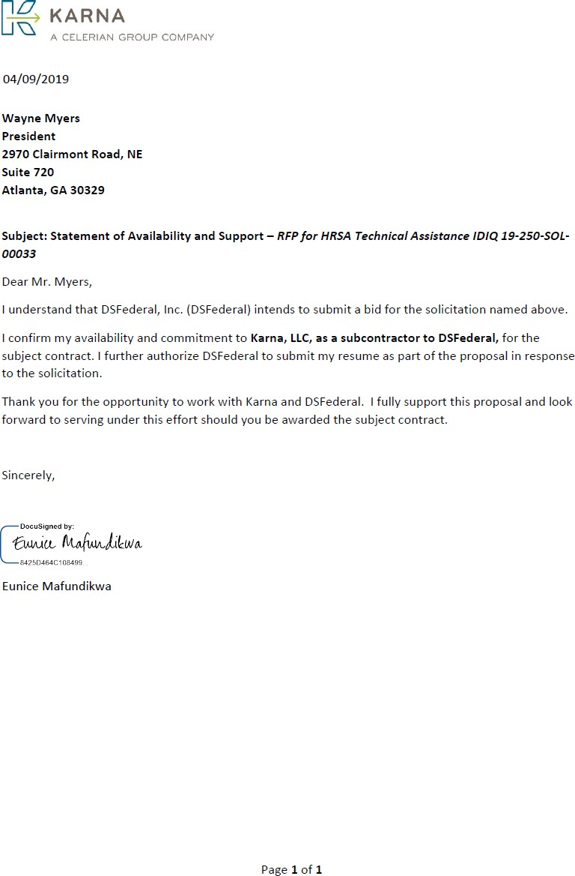

|  |
| --- |
| Qualifications and Experience  Over 25 years of technical assistance to state, federal and international/ global programs  Expertise in building telehealth services capacity |

1. **Alison Amoroso – Research Analyst/Writer**

## Career Summary

An experienced executive lead research analyst capable of directing large, complex task orders and research projects, with expert knowledge of health policy, systems and strategies, rural health, reproductive health, infectious diseases, strategic planning and direction of federally funded programs.

## Education, Training, and Certifications

* Harvard University Graduate School of Education, Master of Education, Cambridge, MA, 2001
* Duke University, Bachelor of Science in Psychology, Durham, NC, 1987

## Work Experience

Health Scientist, February 2018 – Present

Karna LLC, Atlanta, GA

Project: Centers for Disease Control and Prevention/ NCCDPHP/Associate Director of Science Office

* Provide technical assistance to division scientists, evaluators, and leadership to prepare and improve the quality of studies, surveys, evaluations, and any other information collection in order to comply with PRA and receive OMB approval. Assist the programs by writing and editing the ICR as needed.
* Review NCCDPHP and OD/ICRO resources and training documents for accuracy, timeliness, readability, and duplication, and recommend updates to the ADS. Develop updated, combined, or new documents as needed.

Project Director September 2016 – July 2017

Pacific Island Health Officers Association, Guam

Project: Zika and Public Health Emergency Response Project

* Directed $2.3 million in CDC/OPHPR cooperative agreement funds to control Zika outbreak and build public health capacity in the US-affiliated Pacific Islands.
* Analyzed public health emergency laws in four affected territories and advised governors, a parliament, a legislature, health directors, and emergency managers on how to utilize to prevent the spread of disease and survey current outbreaks.

Consultant 2002 – 2010, 2002 – Present

AA Consulting

Project: Zika and Public Health Emergency Response Project

* Collaborated with the Southeastern Telehealth Resource Center and documented all FQHCs in Georgia and capacity for telehealth.
* Performance evaluation consultant with the Rechtman Consulting Group, Atlanta for Jacksonville city government.
* Editorial director for two print/online trade journals and 2 enewsletters in health care policy and benefits.
* Partial Client list: Pacific Human Resources Services, Georgia Network to End Sexual Assault, Field Media (health policy trade journals), SCLC, Georgia Dept. of Substance Abuse, CHAMPS/IANPHI, Atlanta Coalition Against Tobacco (interim director).

Public Health Advisor, Mechanism Lead February 2015 – February 2016

DGHP, Center for Global Health, CDC, Atlanta, GA, Project: Zika and Public Health Emergency Response Project

* Developed, edited, and managed print and online publication of the 5-year strategic plan that charts CDC's new global immunization strategy.
* Responsible for the technical, scientific, and programmatic aspects of six cooperative agreements including funds from ARRA and the ACA and for one Native American tribe, ensuring that partners fulfill terms of the agreement.
* Analyze and contribute to various high-level reports, such as HHS strategic plan; testimonies to Congress from CDC and other federal agencies; high-level committee reports; U.S. Government plans for maternal and child welfare; USG diplomacy documents.
* Contribute to and analyze written briefings for CDC director, HHS Secretary Sebelius, Admiral Goosby, Admiral Ziemer (US Malaria Coordinator), Center for Global Health's director, and Congress persons visits in-country and to CDC.

Communications Specialist September – October 2010 SRA International, Atlanta, GA

CDC, OSELS/PSHPO

* Assisted acting associate director of communication with projects; provided guidance to fellows and FTEs for state program evaluation project.

Vice President for External Relations February 2009 – August 2010 Georgia Budget & Policy Institute. Atlanta, GA,

* Developed one and two-page syntheses and translation of complex legislative directives, departmental policy issuances, and executive directives for legislators and advocates.

## Publications and Awards (select)

* *Vaccine, “*Attitudes about vaccines to prevent Ebola virus disease in Guinea at the end of a large Ebola epidemic: Results of a national household survey,” July 2017, contributor
* Hirsutism, A Women’s Book, Your Health Press, 2009; author
* Our Bodies Ourselves, Simon and Schuster; 2009, 2006 editions; author and editor

# Alison Amoroso - Statement of Availability

|  |
| --- |
| Qualifications and Experience  Research associate with 15 years of experience in child welfare research  B.S. from Georgetown University |

1. **Marneena L. Evans - Quality Program Specialist Summary**

Marneena Evans is a research associate with more than 15 years of experience in child welfare research and evaluation and qualitative development and dissemination. She conducts qualitative data collection and analysis for evaluations. As a continuous quality improvement (CQI) and evaluation

lead on tailored services projects, she supports tribal programs in building their capacity to collect, manage, analyze, and report data and to monitor and evaluate their programs. Ms. Evans previously conducted qualitative data collection and analysis and worked with county child welfare agencies.

# Education

B.S., Foreign Service, Georgetown University, 2000

# Relevant Project Experience

*Westat (2000 to Present)*

**Third-Party Evaluator for Performance-Based Child Welfare System (PBCWS) (1831) Client:** Michigan Department of Health and Human Services

Westat is leading a rigorous evaluation of a 5-year PBCWS project for the placement of children in out-of-home foster care in Michigan. The process evaluation design, for which Ms. Evans conducts qualitative data analysis, includes a participant satisfaction survey, review and analysis of administrative data from state and provider data systems, interviews and focus groups with key stakeholders and staff, and site visits.

# National Child Welfare Capacity Building Center for Tribes (CBCT) (1691)

**Client:** Administration for Children and Families, U.S. Department of Health and Human Services (HHS)

CBCT is the focal point for coordinated and culturally competent capacity building training and technical assistance to Title IV-B and IV-E programs in American Indian and Alaska Native Nations. Westat is responsible for developing universal products, webinars, and tools on data use for management, Continuous Quality Improvement, GIS and child welfare, and the use of technology for data reporting and management. Westat also works directly with tribal child welfare agencies on capacity building projects in these topical areas. As the continuous quality improvement (CQI)/evaluation lead on tailored services projects, Ms.

Evans supports tribal programs in building their capacity to collect, manage, analyze, and report data and to monitor and evaluate their programs. She also chairs the Tools for Growth data products workgroup, which develops data and CQI-related resources and tools for tribal child welfare programs.

**Michigan Title IV-E Waiver Demonstration Project Protect MiFamily (1489) Client:** Michigan Department of Human Services

Michigan’s Protect MiFamily Program provides an innovative array of prevention services to families with young children who are at high or intensive risk for maltreatment as determined by child protective services. The demonstration is being implemented by private agencies in Kalamazoo, Macomb, and Muskegon Counties. Westat is conducting an independent evaluation of each waiver demonstration project. Westat’s activities involve evaluation plan and methodology development; implementation of process and outcome evaluations; primary and administrative data collection; outcome measurement and analysis; cost-benefit and cost- effectiveness analysis; and preparation of reports. Ms. Evans conducts qualitative analysis for the process evaluation and conducted site visits to child protective services and agency offices at demonstration sites.

# Evaluation of the Permanency Innovations Initiative (PII)

**Client:** Administration for Children and Families, U.S. Department of Health and Human Services (HHS)

Westat and its subcontractors are conducting cross-site and site-specific evaluations of the interventions in state or county child welfare systems intended to reduce long-term foster care and improve outcomes for children who experience serious barriers to permanency. Activities include completing the designs of rigorous site-level evaluations, implementing the evaluations, collecting and analyzing administrative data on distal outcomes, studying the implementation process, and conducting a cost study to assess the resource requirements of grantees’ interventions. Ms. Evans conducts qualitative analysis and reporting, manages dissemination approval and tracking between PII grantees and the client, and helped develop the dissemination plan. She also developed and administers the evaluation’s SharePoint site, which is used by Federal staff, grantees, and the training/technical assistance and evaluation teams.

**National Resource Center for Child Welfare Data and Technology (NRC-CWDT) (8754) Client:** Children’s Bureau, Administration for Children and Families, U.S. Department of Health and Human Services (HHS)

The goals of the NRC-CWDT were to assist state and tribal child welfare agencies in (1) developing and improving information management systems related to child welfare; (2) building capacity in using data from statewide child welfare information systems and other sources; (3) developing and improving use of new technologies; and (4) promoting and assisting in the exchange of data between child welfare agencies and the family and juvenile courts, to better integrate policy and practice and improve service delivery and outcomes for children and families. As a subcontractor, Westat provided technical assistance to states and tribes, developed and maintained the NRC-CWDT website, participated in the NRC-CWDT annual conference, and evaluated NRC-CWDT activities.

# Publications

Lorthridge, J., Evans, M., Heaton, L., Stevens, A., and Phillips, L. (2018). Strengthening family connections and support for youth in foster care who identify as LGBTQ: Findings from the PII- RISE Evaluation. Child Welfare, 96(1), 53-78. Available at: https://search.proquest.com/docview/2056448552?accountid=28100.

# Marneena L. Evans - Statement of Availability

|  |
| --- |
| Qualifications and Experience  Over 20 years of corporate and project financial management  B.S. Finance, Virginia Polytechnic Institute and State University  HRSA Director’s Award for Technical Assistance. November 2017. |

1. **Frank Van Balen - Corporate Monitor**

## Career Summary

Mr. Frank Van Balen is a finance specialist with extensive experience in all aspects of corporate and project financial management (both government and commercial entities) with the ability to work with senior level managers to improve financial performance. He has proven success in managing large and small projects, improving operations, increasing business growth and maximizing profits through proactive

financial management, cost reductions, internal controls and productivity improvements.

## Education, Training, and Certifications

B.S. Finance, Virginia Polytechnic Institute and State University

## Work Experience

Business Finance Manager 03/2014 – Present

DSFederal, Inc., Rockville, MD

Responsible for providing financial advice and support to clients and colleagues to enable them to make sound business decisions.

* + Proposal support in the development of the business volume for opportunities the company may be pursuing. Develop and fine-tune price to win strategies to maximize win potential.
  + Provide and interpret financial information and analyze changes to provide senior management with decision making recommendations.
  + Assist project management team with contract interpretation and provide support with project start-up and execution.

Principal 07/2012 – 02/2014

Van Balen Consulting, Annandale, VA

Provide financial and business development consulting services to small, emerging firms seeking support in establishing policies and procedures, effectively managing projects and proposals, capturing and reporting out meaningful data/metrics, controlling costs and creating an environment for growth, financial consistency and project profitability.

* + Startup and execution assistance in managing small projects to properly account for revenue, costs and invoicing, manage staff, track and meet all deliverables, and interface with client to meet all management expectations.
  + Sales and capture support that includes tracking sales and marketing activities, pipeline development, full lifecycle capture management, proposal management, and price to win strategies.

Various 10/2005 – 07/2012

SRA International, Fairfax, VA

SRA, a privately held company generating more than $1.8B in annual revenue, is a leading provider of technology and strategic consulting services and solutions to clients in national security, civil government, and health care. My responsibilities at SRA include financial planning and analysis, revenue and profitability analysis for multiples business units, financial

reporting, and audit assistance. My experience spans direct billable project management on large complex projects to financial analysis support to project managers and senior management.

Contract Manager 07/2011 – 07/2012

* + Responsible for managing the set-up of a PMO to support the award of the VA T4 IDIQ contract.
    - Streamlined internal processes to be able to respond to TO requests with 10 day response times.
    - Worked as proposal manager and pricing manager for multiple TO requests and was also engaged in contract set-up and execution as TO’s were awarded.
    - Required very detailed organizational and time management skills and the ability to manage resources and capture and process information very quickly.
    - Required active monitoring of IDIQ activity and coordination of 32 subcontractors under the IDIQ.
    - Needed to be available at all times and be able to respond quickly and timely to data calls.

Finance Manager 03/2008 – 06/2011

* + Responsible for the overall financial management of the FDA (ORA) MARCS (Mission Accomplishments and Regulatory Compliance Services) IDIQ. This was a single award IDIQ that was awarded to assist ORA to replace failing legacy systems with reusable fail safe architecture and infrastructure to help meet FDA’s mission. At its peak, there were 15 active task orders running concurrently with the majority of those being FFP (software development), with a few T&M (management and support).

Chief Financial Officer 2001 – 2005

Hargrove Inc., Lanham, MD

Ensured financial information and systems integrity for this $34M trade show and special events producer. Accountable for all aspects of financial analysis and reporting, human resources, payroll, AP, AR, billing, benefits, IT support, external audit interface, and budgeting.

Vice President, Finance 1995 – 2001

Controller 1990 – 1994

Accounting Manager 1986 – 1989

Cini-Little International, Inc., Rockville, MD

Managed all accounting operations of this $10 million international commercial foodservice design and management consulting firm with 6 separate operating entities in 8 domestic and 5 international offices.

## Publications and Awards

* HRSA Director’s Award for Technical Assistance. November 2017.
* “Review of Alternative Payment Report,” Report to HRSA, January 2010.

|  |
| --- |
| Qualifications and Experience  Practicing Physician and Medical Epidemiologist  Over 20 years of medical informatics experience, including 6 years of telehealth integration and operations |

# Randy Durbin - Rural Project Manager / Director

## Career Summary

Dr. Durbin is currently the Vice President of Medical Affairs for Karna, LLC, leading the Commercial Healthcare and Population Health Management Division. Dr. Durbin is a licensed physician with emphasis on preventive medicine/wellness/public health, medical informatics and telemedicine, occupational medicine and urgent care, and outpatient medically assisted opioid use disorder treatment. He has over 23 years of experience in healthcare, public health and health informatics, and over 28 years of experience

in database programming and statistical analysis. He has worked in healthcare quality improvement and consulting for Northwestern Memorial Hospital of Chicago, the Baptist Health System of Alabama, United HealthCare South, Inc., commercially, and for the government with the Centers for Disease Control and Prevention (CDC), the Health Resources and Services Administration (HRSA), the US Northern Command (US-NORTHCOM), and the Alabama Department of Public Health (ADPH). He has conducted Lean Health training for hospital executives and line managers, physicians, and scheduling staff. He has published and is a peer reviewer in peer-reviewed public health journals and health blogs and has lectured frequently.

EDUCATION, TRAINING, AND LICENSES

D.O., Kentucky College of Osteopathic Medicine, University of Pikeville, 2007 M.S.P.H., Epidemiology, Emory University Rollins School of Public Health, 1997 B.A., Economics, Psychology, Emory University, 1992

Civil Surgeon expires January 2027

PROFESSIONAL EXPERIENCE

# Karna, LLC 2018 - present

**Vice President, Medical Affairs, Atlanta, GA**

**Statement of Applicability - Telehealth, health systems strategic consulting, substance use disorders, applied public health, business development, and healthcare delivery**

* Leading the Commercial Healthcare and Population Health Management Division
* Serves customers across commercial health payers, healthcare delivery systems, and government/non-government systems.
* Subject matter expert for strategic planning, M&A, clinical telehealth integration, training, compliance, clinical integrity, business development.

# Concentra 2018

**Director of Medical Operations, Atlanta, GA**

**Statement of Applicability – Telehealth, clinical leadership, healthcare quality improvement, training, consulting, and business development**

* Led operations for 21 occupational medicine and urgent care centers in Georgia, with annual revenue of over $57M/year.
* Directly supervised more than 95 physicians and mid-level providers.
* Lead M&A, clinic integration, training, compliance, clinical integrity, and business development.

# U.S. HealthWorks

**Regional Medical Director - (GA, KY, NC, TN), Atlanta, GA 2017 – 2018**

**Area Medical Director, Atlanta, GA 2016 – 2017**

**Statement of Applicability – Telehealth, healthcare quality improvement, training, consulting, and business development**

* Led operations for 17 occupational medicine and urgent care centers in 4 states, with annual revenue of over $25M/year.
* Responsible for the direct supervision of more than 65 physicians and mid-level providers.
* Lead M&A, clinic integration, training, compliance, clinical integrity, business development.

# C&C Health, LLC January 2015 – present

**Medical Director/Physician, Doraville, GA**

**Statement of Applicability – Primary patient care, serving ethnically underserved adult patients for acute and chronic pain**

* Led all outpatient primary care clinic activities.
* Director of all Continuous Quality Improvement (CQI) and Lean Health efforts system-wide.

# Kentucky Addiction Physicians, LLC, d/b/a Wellness Centers of Kentucky 2014 – 2016 V.P./Chief Operations Officer/Physician, Ashland/Georgetown, KY

**Statement of Applicability – Rural health, patient care, outpatient opioid use disorders**

* COO and partner of several outpatient addiction facilities throughout Kentucky.
* Responsible for day to day operations.
* Performed outpatient medical opioid dependence therapy, outpatient wellness testing and therapies.

# McKing Consulting Corporation 2013 – 2016

**Director, Medical Epidemiology and Health Science Atlanta, GA**

**Statement of Applicability – Applied epidemiology and research project management** Senior Scientist in charge of Applied Epidemiology and Public Health research and consulting, Lean Six Sigma coaching and consulting, Medical Informatics integration, and Management Consulting for government (CDC, VA, FDA, HRSA, State Health Departments) and commercial customers (hospital systems, multi-specialty clinics, private practice).

# Other Positions

Dr. Durbin has held research, consulting, and analysis positions since his graduation from Emory in 1992. He has several publications.

# Randy Durbin - Statement of Availability

|  |
| --- |
| Qualifications and Experience  Over 25 years of public health leadership positions at CDC (22 Years) and in New York City with the Urban Research Institute.  Health Disparities Champion Award  Columbia University, Doctor of Education, New York, NY |

1. **Imani Ma’at - Rural Research Analyst/Advisor**

## Career Summary

A project manager and program evaluator with expertise in managing complex government projects on various health initiatives e.g. REACH 2010 -racial disparities and health equity, and HIV/AIDS.

## Education, Training, and Certifications

* Columbia University, Doctor of Education, New York, NY, 1996
* Harvard University, Master of Educational Administration, Cambridge, MA 1982
* Massachusetts Institute of Technology, Master of City Planning, Cambridge, MA, 1981
* Mount Holyoke College, B.A. Urban Studies, South Hadley, MA 1979

## Work Experience

Manager, Inmate Services September 2017 – Present DeKalb County Sheriff’s Office

* Manages all Educational Programs for the DeKalb County Sheriff’s Office and Jail.
* Manages and Supervises Volunteers and Consultants with Options for Living and Learning Program.
* Supervises staff
* Interfaces with and internal partners in Sheriff’s Office regarding educational services for inmates.
* Interfaces with local agencies and programs regarding re-entry program and services.
* Directs and manages contract and task orders; defines project tasks and resource requirements and presents reports defining project progress, problems and identify solutions.

CEO

Focused Health, Inc. August 2008 – Present

* Conducts and analyzes qualitative research including but not limited to focus groups and in- depth interviews for Public Health and Educational Research.
* Coordinating entity for 2 health programs: Youth Educational Services, (Y.E.S.) 4 Health, Inc, and Healthy Haiku 4 Youth. Clients have included DeKalb County Sheriff’s Office, Morehouse School of Medicine, American Cancer Society, Kaiser Permanente, schools, mentoring organizations, churches and other youth-serving organizations.

Several Senior Level Positions

Centers for Disease Control and Prevention (CDC) September 1988-September 2010

*Senior Health Disparities Specialist*

* Community Health and Program Services Branch, Division of Adult and Community Health, National Center for Chronic Disease Prevention and Health Promotion.
* Served as Lead Health and Behavioral Scientist addressing and managing Projects related to Health Disparities Elimination.

*Program Director.* Division of Adult and Community Health, National Center for Chronic Disease Prevention and Health Promotion.

* Served as the Director of the Racial and Ethnic Approaches to Community Health (REACH 2010) Demonstration Program, a national program to eliminate disparities by year 2010.
* Managed REACH 2010 budget of $35 million.
* Represented REACH 2010 at Congressional briefings and to Legislative bodies.
* Served as liaison and forged new partnerships with Department of Health and Human Services (DHHS) agencies and private sector foundations, businesses and member organizations such as the National Association of County and City Health Officials (NACCHO).

*Supervisory Health Scientist.* Community Assistance, Planning and National Partnership Branch, DIV. HIV/AIDS,

* First Team Leader and creator of the Science, Evaluation, and Technology Transfer (SETT) Team. Hired, supervised and managed SETT staff and projects; served as lead Behavioral Scientist for CAPNP Branch;
* Assisted with Scientific data collection and analysis for Branch.
* Initiated and coordinated the African American component of the HIV Prevention People of Color Initiative for CDC which resulted in Congressional appropriation of $156 million additional funding to reduce disproportionate impact of HIV within African American and Hispanic communities.

## Publications and Awards (select)

* 2010 – Health Disparities Champion Award – in Recognition of service as a Health Disparities Champion to Eliminate Health Disparities and Advance Health Equity.
* Ma’at, Imani, October, 2015. Healthy Haiku 3: How to Fight Childhood Obesity One Poem at a Time. Atlanta, GA. ISBN: 978-0-9816305-2-6.
* Ma’at, Imani, May, 2010. Haiku Poetry: Using Creative Expression to Transform Youth. Y.E.S. 4 Health, Inc. Publisher. Atlanta, GA. ISBN: 978-0-9816305-1-9.
* Ma’at, Imani. July 2008. Promoting Healthy Knowledge, Attitudes and Behaviors Among Youth Using Haiku and Creative Expression: A Training Manual for Mentors. Atlanta, GA: Focused Health, LLC. ISBN: 978-0-9816305-0-2.
* Ma’at, Imani, Owens, M., Hughes, M.. “REACH 2010 Coalitions: Reaching for Ways to Prevent Cardiovascular Disease and Diabetes,” Journal of Women’s Health and Gender- based Medicine. Journal of Women’s Health & Gender-Based Medicine. Vol 11, No. 10, Nov. 2002.

# Imani Ma’at - Statement of Availability

|  |
| --- |
| Qualifications and Experience  Skillful in developing comprehensive reports  Capable of publication development writing and creating conference presentations  Georgia State University, Doctor of Philosophy, Epidemiology, Atlanta, GA |

1. **Malikah Waajid - Social Science Analyst (Maternal and Child Health)**

## Career Summary

An evaluation specialist with over 10 years of experience in conducting literature reviews, developing technical documentation, and summarizing key findings in data analyses. Expertise in research writing and recommending new approaches to enhance program delivery.

## Education, Training, and Certifications

* Georgia State University, Doctor of Philosophy, Epidemiology, Atlanta, GA 2017
* Georgia State University, Master of Public Health, Social Behavior and Health Promotions, Atlanta, GA, 2017
* Ithaca College, Bachelor of Arts, Psychology/Neuroscience, Ithaca, NY 2005

## Work Experience

Evaluation Specialist (multiple projects) December 2017 – Present Karna, LLC, Atlanta, GA

* Execute a literature review identifying meta-analytic, evidence- based interventions for

weight management among special populations

* Synthesize findings on weight loss best practices that included metrics on impact, strength of the evidence, effect size, internal validity and external validity, return on investment and innovation for Blue Cross Blue Shield of South Carolina (BCBS-SC) leadership
* Consult with BCBS-SC stakeholders to establish population needs, evaluation capacity and intervention feasibility
* Collaborate on a comprehensive report that detailed the findings of the literature review, environmental scan and provided evidence-based recommendations
* Led the design of the evaluation plan, evaluation framework and logic model for the BCBS- SC employee wellness program
* Conduct descriptive statistics and predictive models to assess reductions in hospital readmissions, and length of hospital stay between intervention and control groups
* Engage stakeholders to develop goals and objective for strengthening evaluation capacity
* Develop a comprehensive report detailing organizational strengths, challenges and opportunities for capacity building and readiness for evaluation
* Prepare work plans for the evaluation project
* Utilize human-centered design (HCD) principles to assess the client’s evaluation needs and opportunities for further development
* Direct the development of the evaluation logic model, methods and protocols in collaboration with the Karna team and CDC executives
* Develop highly- visible written reports of evaluation findings which included, trend analysis, data visualizations and recommendations for leadership
* Create workplace scorecards to assess the employee work experience and managerial relations within the OCOO
* Provide management consultation for data- driven organizational improvements including business and process redesign, business practices, and accountability

IDEX Fellow, Program Evaluator July 2015 – January 2016 Noora Health, Bangalore, South India

* Co-authored a journal publication on the efficacy of a health promotion intervention in a tertiary hospital in Kolkata, India
* Collaborated on the design and piloting of health messages for the interactive voice messaging programming component
* Recruited and trained local translators and interpreters in study interviewing protocols in rural communities
* Collaborated on evaluation tools including a 30-day follow-up survey
* Developed a home visit toolkit and assessment tools, which included interview questions, environmental scan and protocols

Graduate Research Fellow August 2013- December 2017 Georgia State University, School of Public Health, Atlanta, GA/ Kampala, Uganda

* Designed study for a NIH- funded research grant to examine risk behaviors and outcomes related to violence, HIV and alcohol use among Ugandan youth living in slum communities.
* Wrote the research application for the Georgia State University Institutional Review Board (IRB) and managed amendments to protocol over the course of the study.
* Conducted key informant interviews with community service providers to identify critical gaps in HIV access to care among youth
* Conducted a literature review on gender- based violence in Guyana for the World Health Organization
* Created plain-language reports, data visuals, and presentations, talking points on violence prevention, substance use and HIV for various national and international audiences
* Authored journal publications and conference presentations on HIV risk, alcohol consumption and violence exposure

Senior Research Analyst July 2012- August 2013 University of Maryland, National Study Center (NSC), Baltimore, MD

* Created trend reports, infographics, graphs and tables and other data visuals on injury incidences and fatalities for presentations, reports, factsheets and press releases
* Coordinated youth crash related surveillance efforts as the liaison between the MHSO and NSC
* Provided technical assistance and expert support for data translation for strategic planning

Epidemiologist, Fellow November 2010- May 2012

U.S. Army Public Health Command, Injury Prevention, Edgewood, MD

* Wrote abstracts and technical reports on overweight/obesity, motor vehicle accidents, fitness levels and their relationship to injury outcomes

# Malikah Waajid - Statement of Availability

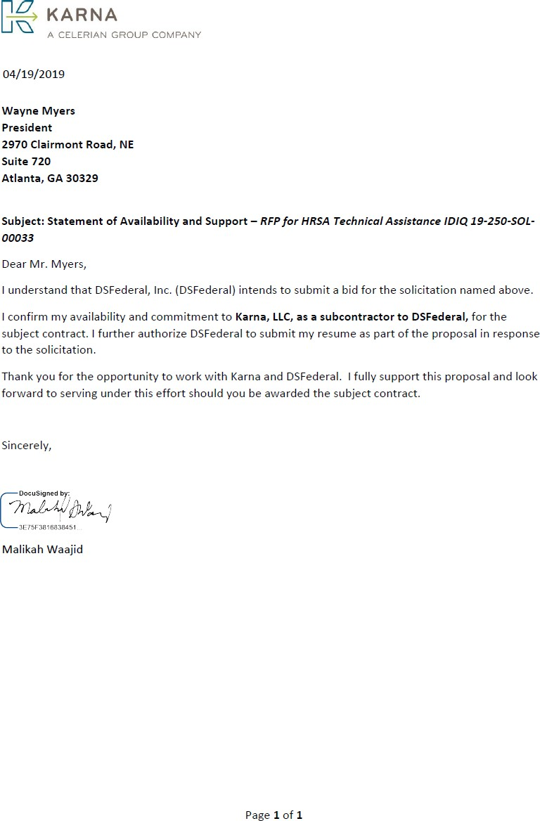

|  |
| --- |
| Qualifications and Experience  Over 18 years of experience as a .NET Developer  Agile, Software application, design, estimation  Web Development  Auburn University, Bachelor of Science, Mathematics |

1. **Claude Fullerton - Website Designer**

## Career Summary

An experienced senior .NET developer and data architect whose experience with and knowledge of a wide range of software methodologies, principles, and architectures provides a sound base for developing, maintaining, and enhancing data management systems. His accomplishments include development of CDC surveys, data collection instruments, and reporting tools in support of CDC and its grantees. He has nine years of experience developing, maintaining, and

enhancing CDC systems and databases, including the Performance Evaluation Reporting System (PERS) web application developed for the Division of Adolescent and School Health (DASH), reports, and data, and more than 15 years of experience with the underlying technologies, tools, and architectures.

## Education, Training, and Certifications

* Auburn University, Bachelor of Science, Mathematics, minors in Computer Science and Physics, 1986

## Work Experience

Data Architect 2015 - Present

Karna, LLC, Atlanta, GA

World Trade Center Program: CDC/National Institute for Occupational Safety and Health (NIOSH)

* Design, develop and maintain the data model and database for the development of the World Trade Center Heath Portal (WTCHP), including support for regular data transfer with the Plexis benefit management system. The WTCHP uses an Azure SQL Server database back- end for an Angular, C#, .NET Core front-end application that uses a REST API.
* Consult regularly with project team and with NIOSH staff on development and evolving requirements for the data model.

Program Evaluation Reporting System (PERS): CDC/ National Center for HIV/AIDS, Viral Hepatitis, STD, and TB Prevention (NCHHSTP), Division of Adolescent and School Health (DASH)

* Develop and maintain PERS, the web application used for Survey administration and data collection. PERS has a front-end built with AngularJS and JavaScript and a back-end REST API built with .NET, C#, LINQ, and SQL Server.
* Develop the reports used with the PERS Survey data to provide DASH and educational personnel with the results of each reporting period along with any other reporting and data

cleaning requirements. The reports are built with Microsoft SSRS and use stored procedures for data retrieval.

Software Engineer 2013 – 2015

Priority Payment Systems, Alpharetta, GA

* Design, estimation, development, and support of applications.
* Administered Agile development methodology.
* Worked with a team of developers on the company’s MXA product, an ASP.Net web forms application for managing the company’s ISOs and merchants. This C# application makes heavy use of JavaScript and AJAX and uses a service layer that talks to the company’s RESTful Web API back-end. The back-end is written in C# and uses a SQL-Server 2012 database with Stored Procedures.
* Worked with a team of developers on the company’s MX Merchant product, an externally facing application that allows the company’s merchants to manage their account with the company. This application is written in JavaScript/AngularJS and uses a service layer that talks to the company’s RESTful Web API back-end. The back-end is written in C# and uses a SQL- Server 2012 database with Stored Procedures.

Senior Web Developer / Team Lead / Primary 2009 - 2013

CACI International, Inc. / Emergint Technologies, Inc., Atlanta GA

* Designed, estimated, developed, and mentored less experienced developers.
* Worked closely with Customers, Business Analyst, and QA staff to develop this multi-tiered ASP.Net MVC 3 system, which uses C#, jQuery, jQuery UI, JSON, AJAX, JavaScript, Web Services, CSS, Entity Framework, LINQ, and SQL 2008 with Stored Procedures.
* These projects used the Agile development methodology.
* CDC/NCEH/ATSDR/DEEHS
  + Worked with a team of developers on a public CDC government website used by health professionals for entering and tracking their required Training and Continuing Education credits.
* CDC/OCOO/MASO
  + Lead developer of team responsible for developing a new Repository of Organization Changes web application for the CDC.
* CDC/ONDIEH/NCEH
  + Lead developer of team responsible for developing a new, multi-agency, public government website by selecting an open-source CMS and making extensive modifications to support the new functionality and design features specified by the customer.
* CDC/NCEH/ATSDR
  + Lead developer of team responsible for reengineering a critical web application used by the entire CDC organization for budget planning and review.
  + Worked closely with Customers and QA staff to integrate conflicting requirements to develop this complex, ASP.Net-based system.
  + Written in object-oriented VB.Net, it makes extensive use of SQL 2008 stored procedures, as well as extensive use of AJAX and custom controls.

# Claude Fullerton - Statement of Availability

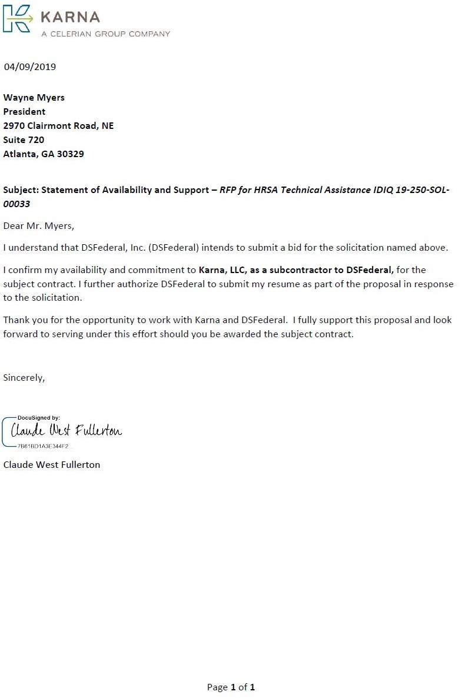

|  |
| --- |
| Qualifications and Experience  Senior Study Director and Registered Nurse  M.P.H. from Columbia University  Manages mixed-methods evaluations |

1. **Shannon Fair Reefer - Senior Researcher / Clinician Summary**

Shannon Fair Reefer is a registered nurse and Westat Senior Study Director with 11 years of experience in health services research and evaluation. She has expertise in managing and conducting multiyear, mixed-methods evaluations, including multiple studies for CMS and AHRQ. Her previous evaluation

work covers other medication management innovations and community based-wellness programs. Ms. Reefer has conducted document reviews, in-depth interviews, focus groups, and site visits. She has managed learning communities, supporting implementation and continuous quality improvement of their innovations or research projects. Her work has also focused on health care quality improvement and identification of best practices in health care service delivery.

# Education

M.P.H., Health Policy and Management, Mailman School of Public Health, Columbia University, 2009

B.S.N. (summa cum laude), University of Pennsylvania, 2005 Certifications and Licensures: Registered Nurse, Pennsylvania, 2005

# Relevant Project Experience Westat (2009 to Present)

**Evaluation of the Part D Enhanced Medication Therapy Management Model (EMTM) Client:** Centers for Medicare & Medicaid Services (CMS)

As project manager, Ms. Reefer oversees all qualitative data collection and reporting for this mixed-methods evaluation of the EMTM model demonstration standalone prescription drug plans (PDPs). Ms. Reefer is leading data collection and analysis, including interviews with industry stakeholders and experts, 22 participating PDPs, and beneficiaries; site visits to a subset of PDPs; and surveys of prescribers and staff implementing EMTM programs.

# Evaluation of Shared Decision-Making and Medication Management Health Care Innovation Awardees

**Client:** Centers for Medicare & Medicaid Services (CMS)

Westat supported CMS’s evaluations of the Health Care Innovation Awards for the medication management (MM) and shared decision-making (SDM) program portfolios involving three SDM and six MM programs on health care utilization and costs; patient health outcomes, quality of life, and satisfaction; and workforce development and satisfaction. Ms.

Reefer led qualitative data collection for the MM portfolio, developed interview protocols, conducted telephone and on-site interviews, conducted case studies, and analyzed qualitative data.

# Medication Therapy Management (MTM) in a Chronically Ill Population: Evaluation Design Report

**Client:** Centers for Medicare & Medicaid Services (CMS)

Westat conducted a qualitative evaluation of CMS MTM programs, a pharmacy-based service provided under Medicare Part D to optimize therapeutic outcomes and reduce the risk of adverse events. The evaluation included an environmental scan, nine case studies, four site visits, expert interviews, input from a technical expert panel and production of a final report. Ms. Reefer created interview protocols, conducted interviews contributed to the technical expert panel.

# Development of Measures of Receipt of Appropriate Clinical Preventive Services by Older Adults

**Client:** Agency for Healthcare Research and Quality (AHRQ)

The purpose of this project was to develop a composite measure(s) for the appropriate use of clinical preventive services for older adults. Westat convened and coordinated meetings of a national steering committee to define and produce a final recommended measure(s). As project manager, Ms. Reefer monitored timely completion of the project and contributed to the management of the National Steering Committee and measure development activities.

# Educational Tools and Resources to Support Meaningful Use of Electronic Records Care Coordination

**Client:** Agency for Healthcare Research and Quality (AHRQ)

The goal of this project was to support Regional Extension Centers (RECs) as they assisted health care providers in achieving compliance with new Federal standards for meaningful use of electronic health records. Ms. Reefer created a draft strategy for research translation and diffusion of care coordination tools, resources, case studies, and leading practices.

# Other Professional Experience

Hospital of the University of Pennsylvania, Philadelphia, PA (2008-2009)

Weill Cornell Medical Center, New York-Presbyterian Hospital, New York, NY (2005-2008)

# Publications, Technical Reports, and Presentations

Carpenter, D., Hassell, S., Mardon, R., Fair, S., Johnson, M., Jr., Nix, M., and Siegel, S (2018).

Using learning communities to support adoption of health care innovations. *Joint Commission Journal on Quality and Patient Safety*, 44(10), 566-573. doi: 10.1016/j.jcjq.2018.03.010 PMID: 30064957

Carpenter, D., Famolaro, T., Hassell, S., Kaeberle, B., Fair, S., Reefer, S., Robins, C., and Siegel, S. (2017). *Patient safety in the home: Assessment of issues, challenges, and opportunities* (for IHI/NPSF). Cambridge, MA: Institute for Healthcare Improvement. Available at: <http://www.ihi.org/resources/Pages/Publications/Patient-Safety-in-the-> Home.aspx.

Piccinini, K., Jacobs, E., Wernecke, M., Alexander, M., Birger, N., Dekmezian, C., Liu, T., Yao, L., Olinger, L., Mercincavage, L., Nooney, J., Fair, S., Cohen, A., Tobin, T., Tang, Z., and Lee,

K.C. (2016). *Wellness Prospective Evaluation: Report on baseline survey efforts and qualitative study of program operations and costs* (for Centers for Medicare & Medicaid Services).

# Shannon Fair Reefer - Statement of Availability

|  |
| --- |
| Qualifications and Experience  Senior Science Writer and Editor  M.S. from Columbia University  Writes and edits articles, factsheets, and guides |

1. **Tina Adler - Technical Writer/Editor Summary**

Tina Adler is a senior science writer and editor with more than 30 years of experience communicating health and scientific advances to the scientific and medical community and to the public. At Westat, she is part of a team supporting communications initiatives for, among other clients, NHLBI’s Office of Science Policy, Engagement, Education, and Communications. She writes and edits content for websites, newsletters, manuals, reports, social media platforms, and other resources. Ms. Adler previously worked as a health and science writer for associations and magazines and as an independent contractor. She edited and wrote news and feature stories, book chapters, news releases, newsletters, and reports. Her clients included government agencies, national associations, and independent publications. She cowrote an award-winning book on Alzheimer’s disease.

# Education

M.S., Journalism (with a concentration in Health, Science, and Environmental Reporting), Columbia University, 1988

B.A., Literature, Hampshire College, 1981

Additional Relevant Training: Planning and Creating Findable, Quality Content (search engine optimization training), JPA Health Communications, 2014; Plain Language: Writing for the Web, DigitalGov University, 2014; Reaching Your Audience: Plain Language Works, Mettger Communications, 2013; NIH Plain Language Online Training, 2012; NLM PubMed Training, 2010

# Relevant Project Experience

*Westat (2010 to Present)*

# NHLBI Communications, Engagement, and Education Support Services BPA – Task Area 4: Health Education and Research Information Dissemination

**Client:** National Heart, Lung, and Blood Institute (NHLBI)

Westat is providing health education, promotion, communications, and research support to NHLBI’s Office of Science Policy, Engagement, Education, and Communications for initiatives aimed at targeted populations, health professionals, and community-based organizations. As senior science writer, Ms. Adler writes articles and factsheets; updates the science, statistics, and language of existing materials; contributes to NHLBI’s Twitter and Facebook posts; meets plain language guidelines; and participates in content development.

**Population Assessment of Tobacco and Health Study (PATH 1.0 and 2.0) Client:** National Institute on Drug Abuse (NIDA)

**Project Overview:** The 2009 Family Smoking Prevention and Tobacco Control Act (FSPTCA) gave FDA the authority to regulate the advertising, labeling, and ingredients of tobacco products. In support of NIDA and FDA, Westat is conducting a large national

longitudinal cohort study of U.S. tobacco users and nonusers (aged 12+). Ms. Adler led development of the study’s first newsletter for participants. She developed the schedule, contributed to content, and worked with a graphic designer to develop the layout and graphic elements.

# Improving Public Health Preparedness and Response to Drought Through the Assessment of Current Knowledge, Practices, and Gaps

**Client:** Centers for Disease Control and Prevention (CDC)

Westat developed a resource guide to augment CDC’s 2010 publication, “When Every Drop Counts: Protecting Public Health During Drought Conditions – A Guide for Public Health Professionals.” As science writer. Ms. Adler wrote and edited the resource guide.

**National Center for Complementary and Integrative Health Information Services Client:** National Center for Complementary and Integrative Health (NCCIH)

Westat provided comprehensive information services support for the NCCIH (formerly NCCAM) Office of Communications from 2009 to 2017. The project team developed or updated more than 100 evidence-based factsheets, research spotlights, continuing education video lectures, and interactive quizzes (some with CME/CEU) each year. Ms. Adler reviewed and analyzed scientific and technical information (e.g., clinical research results and scientific advances) to develop or update in-depth factsheets for the general public and healthcare professionals. She wrote for NCCIH’s Twitter, Instagram, and Facebook accounts and created content for NCCIH’s GovDelivery emails. She also developed and gave presentations on complementary health approaches for staff training.

**Community Guide Communication Technical Assistance and Support Client:** Centers for Disease Control and Prevention (CDC)

**Project Overview:** The Guide to Community Preventive Services (Community Guide) is a repository of evidence-based recommended practices and summarizes the current state of knowledge about effective and efficient disease prevention and health promotion.

# Other Professional Experience

AARP the Magazine, Washington, DC (2010 to 2012)

Freelance Health and Science Writer, Cabin John, MD (1997 to 2010) Equals Three Communications, Bethesda, MD (2002 to 2005) Science News, Washington, DC (1993 to 1996)

The APA Monitor, Washington, DC (1988 to 1993)

National Federation of Business and Professional Women’s Clubs, Inc., Washington, DC (1983 to 1985, 1986)

Burlington Free Press, Burlington, VT (1985 to 1986)

Association of American Colleges, Washington, DC (1982 to 1983)

# Awards and Professional Achievements

Outstanding Book Award (for the Alzheimer’s Action Plan), American Society of Journalists and Authors, 2009

Medical Book Award (for the Alzheimer’s Action Plan), American Medical Writers Association, 2009

# Tina Adler - Statement of Availability

|  |
| --- |
| Qualifications and Experience  PhD in Social Welfare  Licensed Social Worker (LSW)  Experience in TA, training, evaluation, and writing official reports  Award for Excellence, Society for Technical Communication, 2008 |

1. **Tina Bogart Marshall, Ph.D. - Associate Technical Personnel Summary**

Dr. Tina Marshall is a Westat Senior Study Director and licensed social worker with more than 20 years of experience in the health care field, with expertise in mental health and substance abuse policy, health care services for vulnerable populations, and the implementation and evaluation of evidence-based practices using quantitative and qualitative approaches. At Westat, she serves as project manager/lead for evaluation, technical assistance, and product development on SAMHSA, Office on

Women’s Health, Robert Wood Johnson Foundation, SSA, and AHRQ contracts.

# Education

Ph.D., Social Welfare, University of Pennsylvania, 2000 M.S.W., University of Pennsylvania, 1997

B.S.W. (magna cum laude), North Carolina State University, 1992 Certifications and Licensures: Licensed Social Worker (LSW)

# Selected Project Experience

Westat (2003 to Present)

**Interdepartmental Serious Mental Illness Coordinating Committee (ISMICC) Client:** Substance Abuse and Mental Health Services Administration (SAMHSA)

Dr. Marshall was on team completing the Report to Congress. She analyzed and incorporated comments from the public and ISMICC Federal and non-Federal members into the report.

# Cross-Site and Impact Evaluation of Mobilizing Action for Resilient Communities (MARC)

**Client:** Robert Wood Johnson Foundation

Dr. Marshall was a co-evaluator for two sites, conducting interviews/focus groups and analytic review of documents, for this 3-year, multisite evaluation to assess the effectiveness of multisector community efforts to address adverse childhood experiences and promote health.

**Supported Employment Demonstration (SED) Project Client:** Social Security Administration (SSA)

Dr. Marshall is a technical writer and product development manager for this RCT evaluating an integrated mental health and vocational services to people with mental illness recently denied SSA disability benefits. She develops content and manages the website; creates training handbooks, a media KIT, and other resources; and leads development of demonstration videos.

# Division of Services and Systems Improvement (DSSI) Knowledge Synthesis, Documentation, and Marketing Task Order

**Client:** Center for Mental Health Services (CMHS), Substance Abuse and Mental Health Services Administration (SAMHSA)

Dr. Marshall developed online training materials on financing for supported employment and updated the Report to Congress on the prevention of co-occurring disorders. She restructured and finalized six evidence-based and promising practices KITs that included several tools for this knowledge transfer model for CMHS’s Homeless Programs and Community Support.

# Co-occurring Mental Health and Substance Use Disorder (COD) Knowledge Synthesis, Product Development, and Technical Assistance

**Client:** Center for Mental Health Services (CMHS) and Center for Substance Abuse Treatment (CSAT), Substance Abuse and Mental Health Services Administration (SAMHSA) On this large knowledge transfer effort, Westat integrated technical assistance, product development, and Web 2.0 activities. As team leader, Dr. Marshall led five learning communities and managed monthly TA events ranging from interactive webinars to in-person meetings.

# Public Health Approach to Trauma: Creating Conditions, Connection, and Community for Women and Their Families

**Client:** Office on Women’s Health (OWH), U.S. Department of Health and Human Services Westat launched curriculum-based training and technical assistance efforts to communities through OWH regional districts. As project manager, Dr. Marshall managed activities related to regional train-the-trainer sessions and post-training activities.

# Selected Other Professional Experience

Adult Services Division, Department of Mental Health, Washington, DC (2005-2006); Systems Evaluation Center, University of Maryland, Baltimore, MD (2002-2005); American Psychiatric Association (APA), Washington, DC (2001-2002); School of Social Work, George Mason University, Fairfax, VA (1997, 1998, 2000, 2002); Center for Mental Health Policy and Services Research, University of Pennsylvania, Philadelphia, PA (1996- 2000); National Alliance for the Mentally Ill (NAMI), Arlington, VA (1993-2000)

# Awards and Professional Achievements

Award for Excellence, Society for Technical Communication, 2008 Excellence Award, Eastern Evaluation Research Society, 2001

# Selected Recent Publications and Technical Reports

Mulvaney-Day, N., Marshall, T., Downey Piscopo, K., Korsen, N., Lynch, S., Karnell, L., Moran, G., Daniels, A., and Ghose, S. (2017). Screening for behavioral health conditions in primary care settings: A systematic review of the literature. *Journal of General Internal Medicine*. [Advance online publication: September 25, 2017] doi: 10.1007/s11606-017- 4181-0 PMID: 28948432

Interdepartmental Serious Mental Illness Coordinating Committee. (2017). The way forward: Federal action for a system that works for all people living with SMI and SED and their families and caregivers. Report to Congress. Rockville, MD: Substance Abuse and Mental Health Services Administration. Available at: https://store.samhsa.gov/shin/content/PEP17- ISMICC-RTC/PEP17-ISMICC-RTC.pdf.

# Tina Bogart Marshall, Ph.D. - Statement of Availability